**The Shetland Sheepdog Club of WA Championship Show 20th of August 2022**

*It was wonderful to see ‘Working Dogs of Great Beauty’, how lucky was I!*

*Many thanks to the members of the Shetland Sheepdog Club of WA for the invitation to go over a high, quality entry of Shetland Sheepdogs. Congratulations on keeping your size within the Breed Standard. I was very pleased to see short, well let down hocks. While I am passionate about balance, which I am sure you would agree is very important in our breed, most were.*

*The breed is in very good hands in Western Australia. Congratulations to you all, the keepers of our breed.*

*Kim Tresidder*

*Kelanmee Shelties*

[www.kelanmeshelties.com](http://www.kelanmeshelties.com)

Robertson, NSW, Australia

**Best in Show**

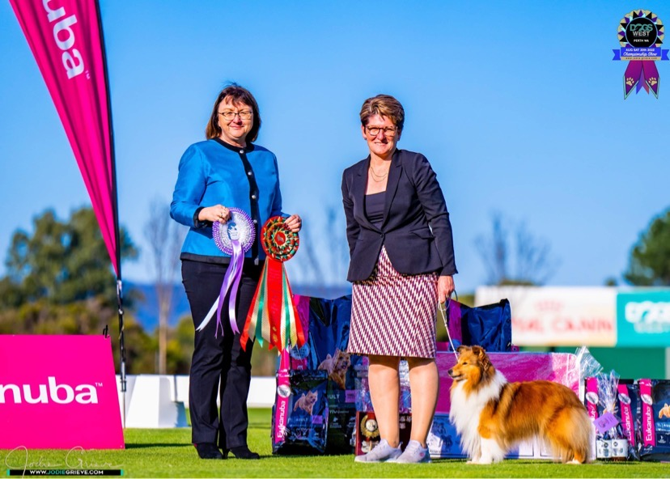

Supreme Ch. Sunland Star Witness – Mrs S Van Dinter and Ms J Van Dinter

|  |  |  |
| --- | --- | --- |
| Dog Challenge  Runner up in Show | Reserve Dog Challenge | Reserve Bitch Challenge |
|  |  |  |

|  |  |  |
| --- | --- | --- |
| Class 1 | Baby Puppy Dog |  |
| 1st | 1. Nightwood Bring on the Night – Ms D Simpson  Very promising 4 month old sable baby. Correct planes, stop and eye shape, with a typical sweet expression. Correct, small ears, wide at base and tipped. Well angulated. Level topline presenting an appealing symmetrical outline. Very good coat for his age. Tail correct length and carriage. Although a little unsettled on examination he was alert, sweet and balanced for his age. |  |
| Class 2 | Minor Puppy Dog – No entry |  |
| Class 3 | Puppy Dog |  |
| 1st | 1. Nightwood Life Inth Spotlite – Ms D Simpson 9 month old sable dog of correct size. Feminine head for a male with a sliding stop. Slightly short in upper arm. Well angulated in the hindquarter. A very showy and alert puppy. Excellent coat. Correct oval feet. A high stepping action when gaiting. |  |
| Class 4 | Junior Dog |  |
|  | 1. Shatrin Blessed Be – absent |  |
| Class 5 | Intermediate Dog |  |
| 1st | 1. Aust Ch. Lurikeen Driveit Likeyastoleit – Ms J Harris & Ms A Stanton 2 year old golden sable dog of correct size. Beautifully presented and handled. Masculine head – correct almond eye, obliquely set, head planes correct; small ears, well used, the whole providing a sweet expression. Although balanced in front and rear angulation, I would prefer a little more length of neck and body. Excellent double coat of harsh texture. Covered the ground well. |  |
| Class 9 | State Bred Dog |  |
| 1st | 1. Arajento Opportunity Knocks – Mrs KC Tonkin   2 year old glamorously marked tri colour dog. Masculine head with a sweet expression. Would prefer a little more length of neck into angulated shoulders. Correct height to length ratio. Still to spring in the chest. Good turn of stifle. Tail to hock. Excellent coat texture, slightly lacking in undercoat. Very good reach in front, slightly toed-in in the rear. |  |
| Class 10 | Australian Bred Dog |  |
| 1st | 1. Aust Ch. Ambermoon Heat of the Night – Mrs C & Miss E Luxford 5 year old tri colour with rich tan markings. This was a very appealing dog who was considered for the Dog Challenge. Very masculine with correctly proportioned head, dark almond eye and small ears. Sufficient length of neck to carry the head proudly. Excellent prosternum, well angulated forequarter. Strong bone. Level topline. Hindquarter balanced with the forequarter. Excellent reach and drive. **Reserve Dog , Australian Bred in Show** |  |
| 2nd | 1. Aust Ch. Arajento Night Fever – Mrs K Tonkin 3 year old Sable dog of correct size. Correct eye, slightly wide in back skull and slight width in ear set. Would prefer tighter, oval feet. Strong bone. |  |
| 3rd | 1. Aust. Ch. Lurikeen Game Set Match – Ms J Harris &  Ms A Stanton 5 year old dog, very showy, correct size. Beautifully presented and handled. Pretty head with a sweet expression. Excellent harsh, top coat and soft undercoat in top condition. Would prefer better spring of rib and depth of chest. Steep over the croup. Slightly wide behind moving out with good reach and drive on side gait. |  |
| Class 11. | Open Dog |  |
| 1st | 10. Supreme Ch. Ambermoon Hear Me Roar - Mrs C &  Miss E Luxford.  6 year old handsome, masculine dog. Shaded sable with a full white collar. Head refined and elegant, correct head planes, small ears, dark almond shaped eye, full muzzle and ample underjaw - all providing a sweet expression. Excellent length of neck, proudly carrying the head. Although a little out of coat still provided ample double coat today which was of correct harsh texture and fitted the body. The gait was smooth and graceful with minimum lift of the feet. Symmetrical outline, nothing out of balance at all from tip of nose to length of tail. The partnership between the dog and the handler in unison. He captured my heart and was worthy of dog challenge. **Runner up to Best in Show**. |  |
| 2nd | 9. Ch. Whoami Nothing But Trouble – Kirsty Erin Post. 2 year old dog of correct size. Another glamourous shaded sable dog with a full white collar. Masculine head, dark almond eye and and correctly placed ears. Would prefer a better length of neck on this boy. He had strong bone and was in excellent coat condition. Motored around the ring. |  |
| Class 12. | Veteran 7+ Dog |  |
| 1st | 29. Ch. Ifonly For The Memories – Debora Greenlee.  9 year old shaded sable dog with a white blaze and collar. Masculine dog with small neat ears. Correct size, slightly longer than tall, would prefer more length of neck. Correct double coat. Slight toe out in the front. |  |

|  |  |  |
| --- | --- | --- |
| Class 1a. | Baby Puppy Bitch |  |
| 1st | 11. Yasdnil Whispers In Th Shadows – J L Mitchell 5 month old tri colour with rich tan markings and a full white colour. Dark almond eye, obliquely placed in the skull, parallel head planes and small ears and she used them well when alert – very sweet expression on this baby. Sufficient length of neck and balanced body proportions with a level topline. Graceful sweep over the croup. Dense rich black coat. She confidently gaited around the ring. A glamorous baby who could not be denied **Baby Puppy In show**. This promising baby has a very bright future! |  |
| 2nd | 13. Ambermoon and Just Like That - Mrs C & Miss E Luxford 5 ½ month sable and white bitch. Another promising young puppy with refined, elegant head and sweet expression. Sufficient length of neck to carry the head proudly. Balanced angulation front and rear, and height to length. Level topline. |  |
| 3rd | 12. Yasdnil Whispers of Magic - J L Mitchell 5 month sable and white bitch. Excellent length of neck. A well angulated baby however is too long in back and carried a soft topline. Out of balance height to length. Good length of tail reaching to hock. Oval feet. |  |
| Class 2a. | Minor Puppy Bitch – None entered |  |
| Class 3a | Puppy Bitch |  |
| 1st | 1. Nightwood Star Ofth Spotlight – Miss K E Post 9 month old sable and white bitch. Right down to size. Feminine head, with a sweet expression. Balance height to length for her size, would prefer length of neck and arch at the crest to give a symmetrical outline. Double coat with harsh texture.  **Puppy in Show** |  |
| 2nd. | 1. Lurikeen Wow Wee Its Just Me – Ms J Harris & Ms A Stanton Just under 12 months of age. Sable and white bitch puppy. Narrow in forechest and needs to develop her spring of rib. Excellent length of neck. Over angulated behind, slight cow hocks. A little unsteady today. Has eyes only for her handler. |  |
| Class 4a | Junior Bitch |  |
| 1st | 17. Arajento Roaring Opportunity – Mrs K Tonkin 14 month old tri colour with excellent tan markings. Feminine head with correct parallel head planes and eye placement, good underjaw. Top third of ear a little flat. Well angulated fore and aft. A well balanced junior bitch with a harsh top coat, lacking undercoat today.  **Junior in Show** |  |
|  | 1. Arajento Jungle Queen – Mrs K Tonkin 14 month old junior bitch. Feminine head. Correct height to length proportions. Narrow in front, would prefer a deep chest and well sprung ribs. Crossed over in front when gaiting and slightly toed out behind. |  |
| Class 5a | Intermediate Bitch |  |
| 1st | 20. Sunland Summer Wind – Mrs S Wildman & Mrs S & Ms J Van Dinter 2 year old sable and white bitch. Very feminine head with sweet expression and symmetrical outline. Well angulated front and rear, level topline. This bitch needs to develop in the chest. Strong bone, not heavy. Very pleasing to examine.  **Intermediate in Show** |  |
| 2nd | 21. Nightwood Don’t You Sass Me – Ms D Simpson 23 month old bitch with a sweet expression. A correctly sized bitch, balanced fore and aft. Level topline. Graceful sweep over loins. Double coat of correct texture. Not the strength of substance of my first place winner. |  |
| 3rd | 19. Ch. Yasdnil Whispers in the Breeze – J L Mitchell 2 year old sable bitch with a very pleasing head, sweet expression. Correct length of neck in to balanced upper arm and lay of shoulder. Short in back. The hindquarters moved with a rolling action and I would prefer her to be balanced fore and aft. Correct double coat in excellent condition. |  |
| Class 9a | State Bred Bitch |  |
| 1st | 22. Supreme Ch. Lurikeen To Glam T Give A Damn - Ms J Harris & Ms A Stanton 6 year old glamorous bitch, right down to size. Red sable with a full white collar. Feminine head, head planes, stop and dark eye – sweet expression. Correct ear set. Sufficient length of neck. Balanced fore and hindquarters. Fabulous level topline. Double coat in great condition. She moved gracefully with a minimum left of the feet. Pleasing to watch that topline on the move! **State Bred in Show** |  |
| Class 10a | Australian Bred Bitch |  |
| 1st | 25.Arajento All In Good Time – Mrs K Tonkin Nearly 4 year old red sable. Correct size and well angulated forequarter and hindquarter. Level topline. Well sprung ribs and excellent double coat. Oval feet. Great reach and drive. |  |
| 2nd | 24. Whoami This Is Me – Kirsty Erin Post 3 ½ year old bitch. A shaded sable bitch of correct size. Dark, almond eye, obliquely shaped. Ears slightly light and would have preferred them to have been correctly tipped forward. Lacking full double coat today. Excellent extension when gaiting. |  |
| 3rd | 23. Arajento Golden Handshake – Mrs K Tonkin 3 ½ year old sable bitch of correct size. In excellent coat condition. Head – skull and muzzle correct with parallel planes and dark almond eye, sweet expression. Small ears. Slightly out at elbows and this was also evident when moving. Oval feet. Well angulated in the hindquarter. |  |
| Class 11a | Open Bitch |  |
| 1st | 27.Supreme Ch. Sunland Star Witness – Mrs S Van Dinter and  Ms J Van Dinter 6 ½ year old richly coloured shaded sable bitch. A lovely well muscled bitch in excellent condition. Refined and elegant, feminine head. Dark eyes with a sweet expression. Ears small, gently tipped. Muscular, arched neck into well laid shoulders. Well sprung ribs, short muscular loin. Level topline. Hindquarters well angulated and balanced her body. Tail to hock, set low. Strong bone. Correct fitting coat, with feathering to her legs and well furnished tail. Her fabulous firm topline was evident, as she moved gracefully around the ring with a minimum lift to her feet, a real pleasure to watch, so sound.  I was privileged to judge this bitch today and couldn’t deny her the B**itch Challenge, Open in Show and Best in Show.** |  |
| 2nd | 26.Arajento Steppin Out In Style – Mrs K Tonkin 3 ½ year old sable bitch. Feminine head, and sweetness in expression. Correct size. A balanced bitch all over, and in excellent coat. Would prefer a smoother transition of topline into tail set although low set. I couldn’t deny her reserve bitch challenge from this class. |  |
| Class 18a | Neuter Bitch |  |
|  | 28. Neuter Ch. Lurikeen Talkn About My Girl Ms J Harris & Ms A Stanton 9 year old sable bitch, very pleasing bitch of correct size. Left ear a little high. Feminine head. Slightly wide in front and elbow. Correct height to length. Level topline. Correct set length of tail. Side gait smooth and effortless. Beautifully handled and presented. **Neuter in Show** |  |

*Photographs were taken on the day as a reference for critiquing. Not professionally photographed.

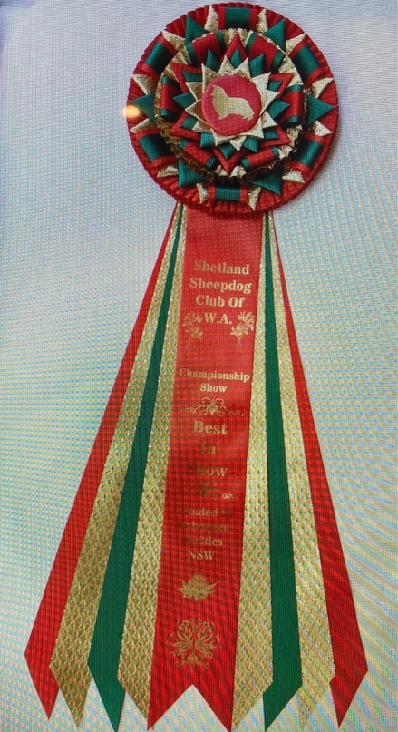

“Bringing the two States together for a day”