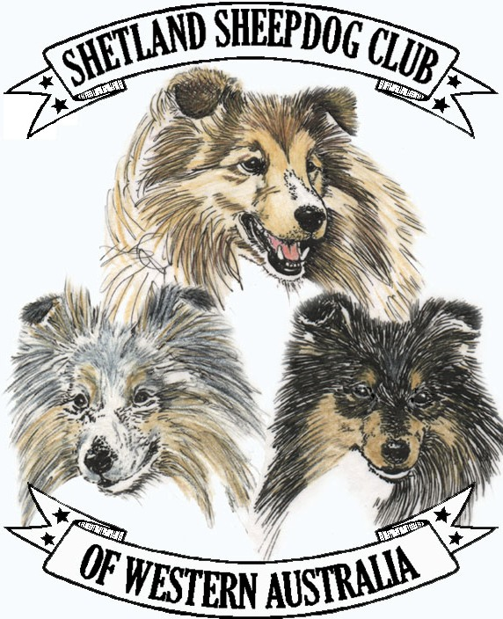

MEMBERSHIP AND RENEWAL FORM 2021

Subs are due on November 1st each year

$20.00 Family  $15.00 Single  $15.00 Associate  New Membership  2021 Renewal 

Name: ________________________________ CAWA M/Ship No (if applicable): __________________

Address: ______________________________________________________________________________

_______________________________________________________________________________________

_______________________________________________________________________________________

Name of Dog: _____________________________________________ Reg No: _____________________

Email: _________________________________________________ Telephone: _____________________

Date: ___________________________

## Send form and cheque to :

Mrs G Hesketh ,
The Treasurer,
SSCWA,
4 Dorchester Turn ,
Canning Vale WA 6155

Or glendahesketh@gmail.com

