NORTHERN BRITISH BULLDOG CLUB Inc

SATURDAY 31ST MARCH 2018

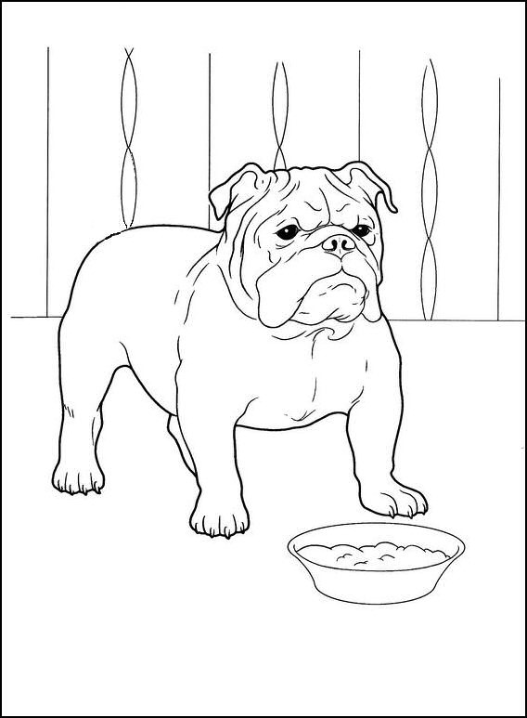

NORTHERN BRITISH BULLDOG CLUB OF NSW INC.

President - Susan Butler

Senior Vice President - Sue Gibbons

Treasurer - Anne Mackinlay

Secretary - Linda Gibbons

Assistant Secretary - Anne Mackinlay

Publicity Officer - Carla Smith

Committee - Lynette Peazley, Bradley Holden, Wayne Cooper, Shane Cooper

LIFE MEMBERS
Wesley Stacey, John Bower

Show Committee
Bradley Holden Lynette Peazley
Shane Cooper Wayne Cooper

We would like to welcome our Judge for today

Mrs Debbie Morrison-Tierney (Qld) her prefix is Stonebridge

This Show is run under the Rules & Regulations of the DOGS NSW, A copy of such regulations may be perused at the Secretaries Office. The Committee reserves the right to alter or amend judging arrangements and to substitute judges if deemed necessary.
Exhibitors Note:
In accordance with Regulations Part 11 Show, It is the obligation of any person at a show who observes a dog behaving in an aggressive manner to report the incident either orally or in writing to a member of the Show Committee as soon as possible on the day of the Show.
The club would like to thank the following for their kind donations and Sponsorship

Rosehip Vital

The club would like to thank the following for their kind donations and Sponsorship

Rosehip Vital
Love Em Pet Treats
TuffRocks
Pet Shop Boys
Susan Butler Sue Gibbons
Linda Gibbons
Michelle & Gary Hartman

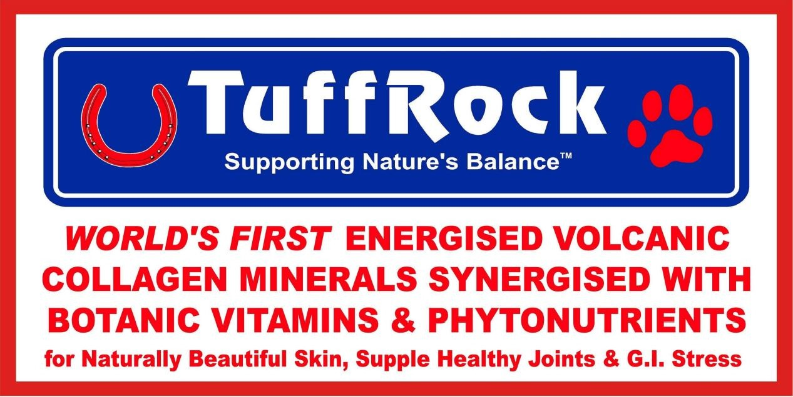

And a special thank you to all the exhibitors who have supported the club by attending today’s show.
NORTHERN BRITISH BULLDOG CLUB OF NSW INC.
CHAMPIONSHIP SHOW

SATURDAY 31ST MARCH 2018
CNCC SHOWGROUNDS HILLSBOROUGH ROAD, HILLSBOROUGH

Judge: Mrs D Morrison-Tierney (Qld)
Judging commences: 10am
Order of Judging: Dogs followed by Bitches
Entry Fees: $10
Baby Puppies $5.00
Catalogues: Free with entry, $5.00 on the day
DogsNSW Representative: Mr D McMillan
Prizes: Category A
General Specials: Trophy & Sash
Special Classes: Property Classes, Veteran, Neuter, Handlers,
Trophy & Sash
Entries to: Secretary, NBBC of NSW Inc
C/o 1 Ginganup Rd,
Summerland Point, 2259
Ph & Extreme Weather Ph 0412-136-050
Cheques made payable to Northern British Bulldog Club of NSW Inc.

ENTRIES CLOSE 26TH MARCH 2018

Baby Puppy Dog  Class 1 |  |  | Entries Nil
Minor Puppy Dog  Class 2 |  |  | Entries 1
1  J P Gemmell |  | LLEMMEGS FAIR AND SQUARE  2100483067 DOB 31/8/2017  Sire: Thistlebull Might N Power  Dam: Llemmegs Tamsen  Breeder: Exhibitor
 |  | First - 1
Puppy Dog  Class 3 |  |  | Entries 1
2 J. P. Gemmell |  | LLEMMEGS GLINT OF ICE (AI)  2100473759 DOB 4/4/2017  Sire: Iceglint I'm Edward (uk)  Dam: Embolden All About Eevee  Breeder: Exhibitor
 |  | ABSENT
Junior Dog  Class 4 |  |  | Entries 4
3 | Mrs S. T. Cooper | BULDOK COOPER  2100472571 DOB 13/3/2017  Sire: Ch Buldok Tim Tam  Dam: Buldok Queen Of The Ring  Breeder: Exhibitor
4 | Mrs S. Dellas | CH SAWYERMOON EARL OF TESTWOOD (AI)  2100462540 DOB 3/11/2016  Sire: NDL Ch Testwood Tom (uk)  Dam: Buldawg Lovely To Look At  Breeder: Exhibitor
5 | Gary Hartman | UNFORGETABUL SARGENT PEPPERS  3100350408 DOB 13/11/2016  Sire: Ch Tamad Sickem Rex  Dam: Embolden Big Bang Beauty  Breeder: Exhibitor
6 | A. C. MacKinlay | HULLABULLULA LORD ELWIN ( AI )  2100472780 DOB 8/3/2017  Sire: Ch Paseya Rising To The Stars  Dam: Ch Ludexby Lady Lulabelle  Breeder: Exhibitor
First – 5 Second – 3 Third - 6

Limit Dog  Class 8 |  |  | Entries 1
7 R & C Smith |  | BULDAWG HANDIWORK  2100425993 DOB 24/02/2015  Sire: Buldawg Hand Made  Dam: Buldawg Heidi  Breeder: Exhibitor
 |  | First.....7..
Australian Bred Dog  Class 10 |  |  | Entries 2
8 | Miss S. Butler | OUSHIINU CATCH A SQUIRTLE  2100455569 DOB 12/06/2016  Sire: Lorabul Mister Mistoffelees  Dam: Oushiinu Wait N See  Breeder: Exhibitor
9 | Mr. G. Hartman | CH TAMAD SICKEM REX  2100417188 DOB 25/09/2014  Sire: Gnd. Ch. Janayin Who Wears Da Pantz  Dam: Dreamrock Dreamz R Coming Tru  Breeder: Exhibitor
 |  | First......8 . Second .....9...

Open Dog  Class 11 |  |  | Entries 3
10 | Miss S. Butler | OUSHIINU WHERES JIGGLY PUFF  2100455571 DOB 12/06/2016  Sire: Lorabul Mister Mistoffelees  Dam: Oushiinu Wait N See  Breeder: Exhibitor
11 | Mrs S. T. Cooper | CH. BULDOK SON OF SAM  2100397016 DOB 2/12/2013  Sire: Ch Buldok Our Samson  Dam: Ch Buldok Lucy Lou  Breeder: Exhibitor
12 | J. P. Gemmell | CH LLEMMEGS SHERMAN TANK  2100439348 DOB 6/10/2015  Sire:Truwinks Prince Fredrick  Dam: Embolden All About Eevee  Breeder: Exhibitor
13 | L. Pezely & L Barnes | CH LORABULL SKIMBLESHANKS  3100301886 DOB 9/12/2014  Sire: Whitehills Southern Cross, (impuk)  Dam: Ichellemay Just Fabulous  Breeder: Miss L Barnes
First.....12.. Second ...10..... Third 13

Challenge Dog .............12..................... pts .................

Reserve Challenge Dog .........5..........................

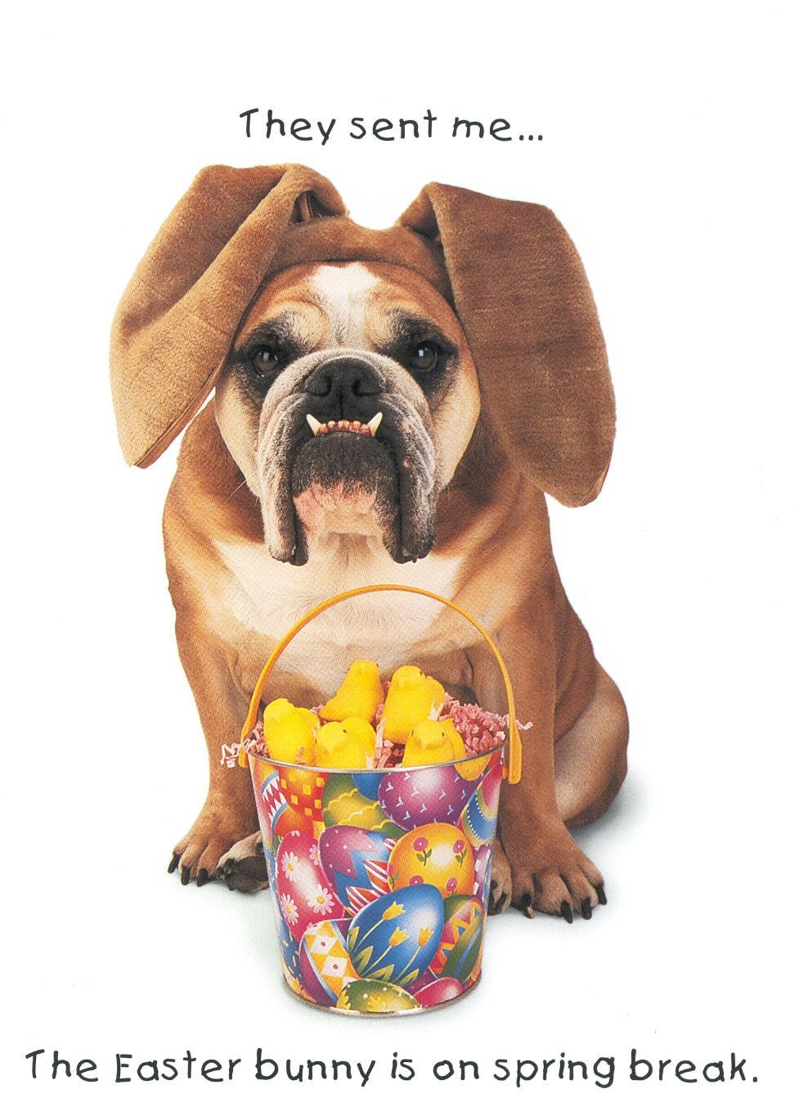

Baby Puppy Bitch  Class 1a |  | Entries Nil
Minor Puppy Bitch  Class 2a |  | Entries 1
14 B. & L. Baker | BOSTONLAKES GET ME SOME OF THAT (AI)  2100477769 DOB 1/07/2017  Sire: Black Treasure Dogs Darius (Hun )  Dam: Bostonlakes Feel Likearockstar  Breeder: Exhibitor
ABSENT
Puppy Bitch  Class 3a |  | Entries 1
15 Gary Hartman | WEWUV GOTTA HAVE FAITH  2100473911 DOB 7/04/2017  Sire: Ch. Bumbullb SumthinTotalk About  Dam: Ch. Tamad Love The Chase  Breeder: Jeoff Levette
 | First....15...

Junior Bitch  Class 4a |  |  |  | Entries 1
16 A MacKinlay |  |  | HULLABULLULA LADY EMELYN ( AI )  2100472799 DOB 8/3/2017  Sire: Ch Paseya Rising To The Stars  Dam: Ch Ludexby Lady Lulabelle  Breeder: Exhibitor
 |  | First....16...
Limit Bitch  Class 8a |  |  |  | Entries 3
17 | Miss S. Butler |  | OUSHIINU LOOKING FOR EEVEE  2100455570 DOB 12/06/2016  Sire: Lorabull Mister Mistoffelees  Dam: Oushiinu Wait N See  Breeder: Exhibitor
18 | Mrs. S. T. Cooper |  | BULDOK MYLOU  2100460652 DOB 16/9/2016  Sire: Ch Buldok Tim Tam  Dam: Ch Buldok Lucy Lou  Breeder: Exhibitor
19 | Mrs S. Dellas |  | BULDAWG LOVELY TO LOOK AT  2100425696 DOB 4/04/2015  Sire: Ch Sawyermoon Lord Grantley [AI]  Dam: Buldawg Paparazzi Target  Breeder: R & C Smith
 |  | First.....18.. Second ...17..... Third .....ABSENT.....
Australian Bred Bitch  Class 10a |  |  |  | Entries 2
20 | Mrs T. Klaack |  | CH RIENBO COOKIES N CREAM  2100459782 DOB 12/9/2016  Sire: Bostonlakes Hell Yeah Turnitup  Dam: Klickclack Naughty N Nice  Breeder: J. O'Brien
21 | R & C Smith |  | BULDAWG BACK TO THE FUTURE (AI)  2100435249 DOB 5/07/2015  Sire: Ch Portfield Monarch (impuk)  Dam: Buldawg Kinectic Energy  Breeder: Exhibitor
 |  | First...21.... Second ...ABSENT.....

Open Bitch  Class 11a |  |  | Entries 2
22 | J. P. Gemmell | CH THISTLEBULL I LOVE LUCY  2100429259 DOB 11/05/2015  Sire: Truwinks Prince Fredrick (ai)  Dam: Thistlebull Pom The Princess  Breeder: Mrs. A. Walker
23 | R & C Smith | CH BULDAWG NEVERGIVIN  2100416624 DOB 21/08/2014  Sire: Ch Gateley Pryce Lee  Dam: Buldawg Papparazzi Target  Breeder: Exhibitor
First..22..... Second ..ABSENT......
Challenge Bitch ......16
Reserve Challenge Bitch .........22
Best In Show ..........12

Runner up Best in Show .....16..............
VETERAN BULLDOG
.......................

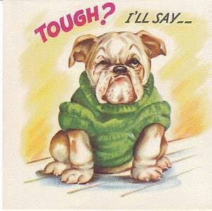
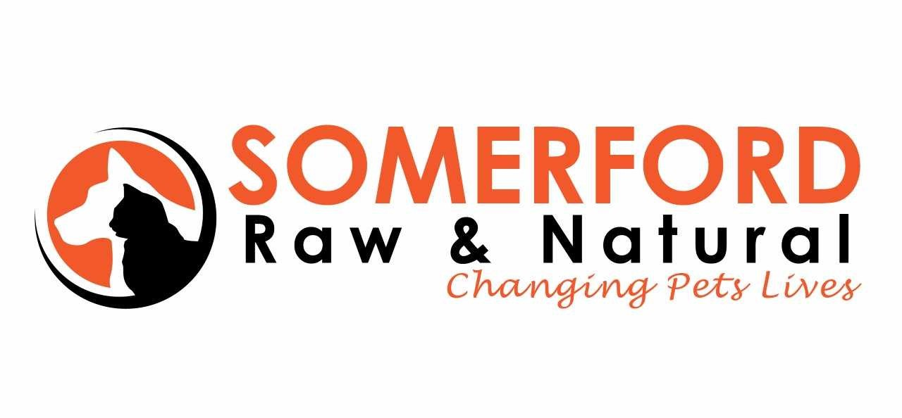

Somerford Raw & Natural is a proud sponsor of The Northern British Bulldog Club Inc.
Using ONLY Australian Grown Human Grade Ingredients
Hunter Valley Chicken and Turkey, New England Beef and Lamb, Tasmanian Salmon

and is manufactured in Newcastle NSW.

The Benefits are immediate: Reduce Tear Staining & Skin Issues
Healthy Teeth & Breath - Your pet will have much-improved breath, minimal tartar build-up, and beautifully clean and healthy teeth.
Healthy Skin & Coat - Persistent skin problems suddenly disappear or improve, no more vet visits, medicated washes, antibiotics, cortisone shots and cortisone tablets.
Optimum Immune System - A good balance of essential fatty acids and other immune normalizing and strengthening nutrients, reduces inflammatory conditions and waves good-bye to infections.
Enhanced Digestion & Absorption of Nutrients - Living enzymes break down and utilize food to maximize the digestive system’s effectiveness.
Stool Volume & Odour - Reduced stool volume and odour, Raw is more readily absorbed than grain fed diets, in the digestive system. Odorous stools are a result of improper or incomplete digestion of nutrients.
Healthy, Lean Body Mass - Lose unwanted fat and gain that much desired increase in muscle mass.
This not only makes your pet look better, it increases your pet’s metabolic rate, its activity levels and its healthy life span.
SOMERFORD RAW IS A COMPLETE & BALANCED DIET
DO AWAY WITH DRY KIBBLE - NO FILLERS - NO CHEMICALS - NO
COLOURING - NO PRESERVATIVES - NO HEAT PROCESSING - NO GRAINS
AVAILABLE IN PUPPY & ADULT VARIETIES CHICKEN & BONE, CHICKEN & VEG, BEEF & VEG,
TURKEY & VEG, SALMON & VEG, LAMB & VEG OR COMBO PACKS
SPECIAL OFFER

MEMBERS OF DOGS NSW SAVE UP TO $45 DISCOUNT ON REOCCURING DELIVERY ORDERS. SPECIAL OFFER

BREEDERS GET A 10% RESELLERS RETAINER FOR THE FIRST YEAR ON ALL ORDERS OF SOMERFORD RAW
THROUGH THEIR PUPPY BUYERS, PUPPY PACKS AVAILABLE TO BREEDERS.

For more information see www.forthepet.com.au or to take up these special offers contact sales@petshopboyz.com.au

General Specials
Judge: Mrs Debbie Morrison Teirney (Qld)

AWARD | Name: | Exhibit No
Best In Show: | Ch Llemmegs Sherman Tank | 12
R/U Best In Show: | Hullabullula Lady Emelyn | 16
Best Baby Puppy In Show: |  | NIL
Best Minor Puppy In Show: | Llemmegs Fair and Square | 1
Best Puppy In Show: | Wewuv Gotta Have Faith | 15
Best Junior In Show: | Hullabullula Lady Emelyn | 16
Best Limit In Show: | Bulldok Mylou | 18
Best Australian Bred In Show: | Oushiinu Catch a Squirtle | 8
Best Open In Show: | Ch Llemmegs Sherman Tank | 12
Best Veteran:

