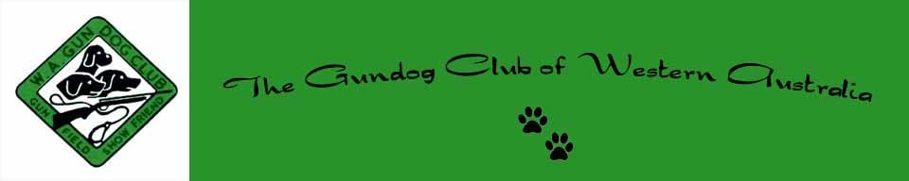
John & Nell Minty Obedience, Rally & Trick Dog Trial
Saturday, 22 June 2024 at Dogs West Lower Oval
Entries close: 10/06/2024
JUDGES:
UDX CDX ----------------------------------------------- Mr F Waring
UD CD CCD--------------------------------------------- Dr D Webb
RALLY MASTER & EXCELLENT ---------------- Ms C Didsman
RALLY ADVANCED & NOVICE ------------------ Mrs S Powell
TRICK DOG ADVANCED & STARTER -------- Ms D Hyde
TRICK DOG INTERMEDIATE & NOVICE ----- Ms A Houston
**The Club reserves the right to reallocate or appoint additional judges as required**
ENTRIES TO:
ONLINE: https://www.topdogevents.com.au
EMAIL: gdcwatrial@gmail.com - with copy of payment
POST: Mrs M Hankinson 32 Wallangarra Drive Bedfordale WA 6112
ENTRY FEES:
MEMBERS: $8.00 NON-MEMBERS: $10.00
BANK TRANSFER BSB: 066 108 ACCOUNT: 00903006 REF: HANDLER NAME
CHEQUES PAYABLE TO "GUNDOG CLUB OF WA INC"
CATALOGUES: FACEBOOK - OBEDIENCE WA
MEMBERSHIP: DUE 01 NOVEMBER EACH YEAR - DOUBLE/SINGLE: $15.00
GATES OPEN: 7:30am
CHECK IN TIME: Obedience 08:30 Rally 09:00 Tricks 10:00
JUDGING TIME: OBEDIENCE: 9:00am RALLY: 9:30am TRICK: 10:30am
TROPHIES: Rosettes 1st place - qualifying scores only
ENQUIRIES: Maggie Hankinson Tel: 9399 6564 / gdcwatrial@gmail.com

