The

Softies Snort

**Official Publication of The British Bulldog Club of NSW Inc.**

|  |
| --- |
| ***JANUARY – FEBRUARY 2025****.* |

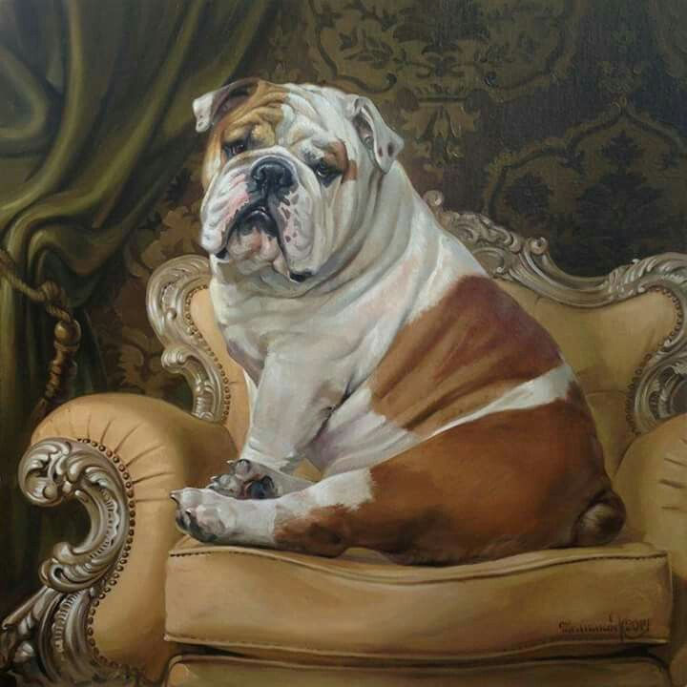

|  |  |  |  |  |
| --- | --- | --- | --- | --- |
| **PRESIDENT**    Mr Chris Small   4 Jarques St  Kandos NSW 2848  Ph: 0409-070-537 | bbcofnswlogo | | **SECRETARY**  Mrs Ann Small  4 Jarques St  Kandos NSW 2848  [annsmall@bigpond.com](mailto:annsmall@bigpond.com)   Ph: 0417- 043- 482 | |
| **TREASURER**    Mrs Tracey Smith  P.O. Box 3  Warragamba NSW 2752  Ph: 0411-882-007 | | | **PUBLICITY OFFICER**  Mrs Carla Smith  3 Jean Street   Greenacre NSW 2190  Ph: 02-9642-7142 | | **ASST SECRETARY**    Mrs Courtney Smith  P.O. Box 7291   Mount Annan, NSW 2567  Ph: 0406-928-105 | |

**MONTHLY MEETING AGENDA**

**VENUE: ZOOM MEETING**

**DATE: Friday 24th January 2025**

**TIME: 7 pm**

**BUSINESS:**

1. President to open the meeting.

2. Apologies.

3. Minutes of Previous Meeting.

4. Business arising from the minutes.

5. Confirmation and adoption of the minutes.

6. Committee's Recommendations.

7. Treasurer's Report.

8. Correspondence (inwards & outwards).

9. Election of New Members.

10. Show Business.

11. General Business.

12. President to Close the Meeting.

**The British Bulldog Club Of NSW Inc.**

**C:\Users\Carla Smith\Desktop\Desktop Pictures\ADD Logos\royal-canin8dda563e14f46f60a5b0ff0000029bfa.png “Easter Championship Show” sponsored by**

**DATE:** **Sunday 13th April 2025**

**TIME: 10.am**

**VENUE:** Ring 12, Bill Spilstead Complex for Canine Affairs 44 Luddenham Rd, Orchard Hills

**JUDGE:** **Mr Josh Grant (NSW)  
  
 CLASSES: 1, 2, 3, 4, 5, 8, 10, 11, 18 Dogs and Bitches** **VETERAN:** Dogs and Bitches 7 years and over.  
  
 **PROPERTY CLASSES:** Best Head, including Ears & Jaw. Best Body, including Best Front & Feet. Movement including Hindquarters with Action.  
 Best Show Condition, Best Parent & Offspring, Best Easter Bonnet.  
 Challenge & Reserve Challenge Winners are not eligible to compete.

**HANDLERS CLASSES:** Best Lady Handler, Best Gentleman Handler,   
 Novice Handler,   
 Fun Classes (learning classes)   
 for Children to be held during Lunch break.   
 Tiny Tots (children 6 years and under) must be assisted by an Adult.  
 Child 7-9 years (can be assisted by an Adult   
 Child 10-12 years, Child 13-17 years

SASH or TROPHY : All Class Winners  
 SASH or TROPHY : All Classes in Show  
 SASH & TROPHY: All Property Class Winners   
 SASH & TROPHY: All Handlers Classes

**Trophy Donors will be acknowledged in the Catalogue**

**ENTRY FEE:** $15 first entry including catalogue, $12 subsequent entries,   
 Neuter Classes, $12. Baby Puppies $5. extra catalogues $3 each

**PROPERTY CLASSES:** $2 for one or all, to be entered on a separate entry form,   
 Easter Bonnet is Free



***Entries Close:*** **Monday 7th April, 2025**

***Entries and all enquiries to:* Cataloguer**

c/o 3 Jean Street  
Greenacre NSW 2190  
Phone: 02-9642-7142 no calls after 9pm please  
**Extreme weather Ph.,** 0429 642 714

*Show Manager:* Mr Chris Small *Assist. S/M:* Mr Hayden Smith  
*Trophy Steward:* Mrs Courtney Smith *Assist T/S:* Mrs Tracey Smith *DogsNSW Rep:* Mrs Trudy Dive *Ring Steward:* T.B.A.  
  
   
**Free Bar-B-Que lunch** for members showing will be supplied, Drinks are a gold coin donation,   
***This show will conducted under the rules & regulations of DogsNSW, a copy of which may be perused at the Secretary’s table.***

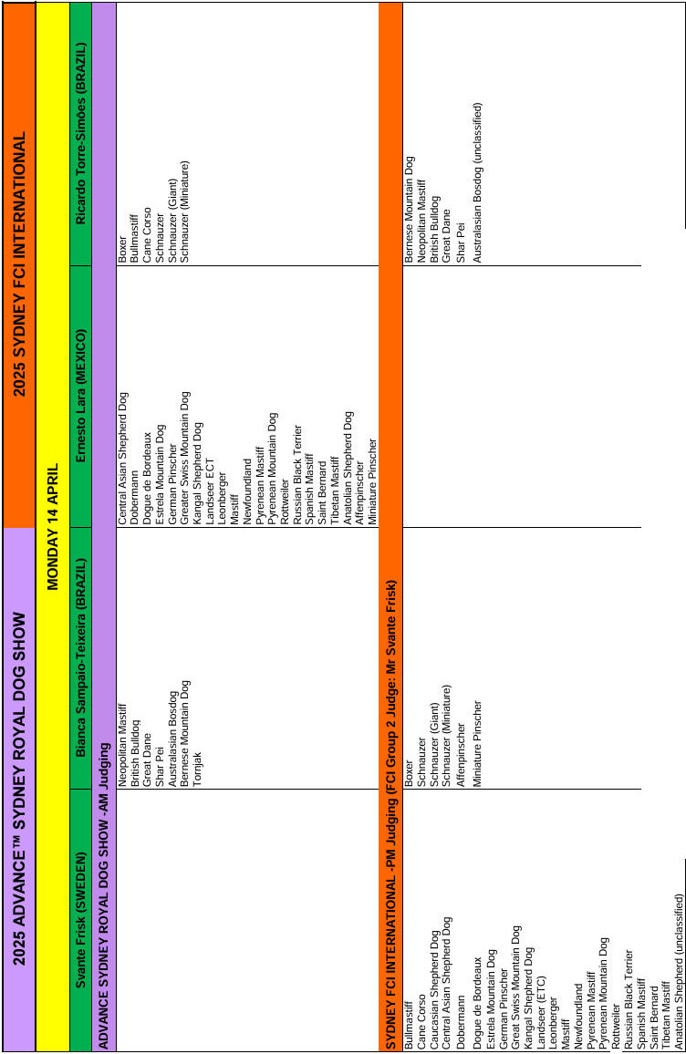

**Meetings**

**Dear members**

**It has been very disappointing that we cannot get more member to log on to our Zoom meetings, we changed to Zoom as members were finding it very hard to attend meetings at Dogs NSW. For our November meeting we couldn’t even get a quorum, so no meeting was held.**

**Some members have advised they were not sure how to log on to zoom, it is very easy all you need to do if you don’t have the zoom app, you will need to go to your app store and download it.**

**It will ask for an ID number which is 83204078804 (this number remains the same) it will then ask you to join the meeting, at this time Courtney will accept you into the meeting.**

**If you have any questions, please don’t hesitate to contact myself or Courtney.**

**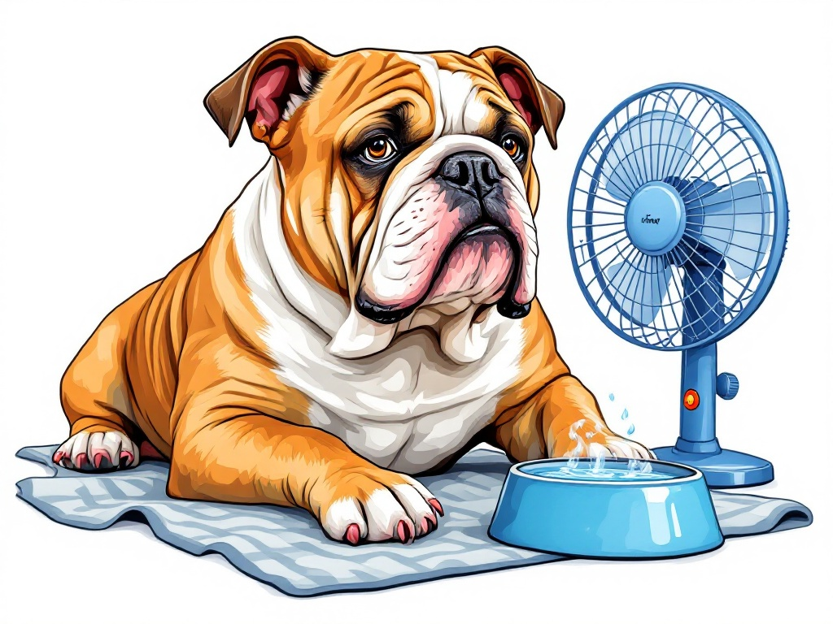  
Kind Regards   
Ann Small   
hon. Secretary.**

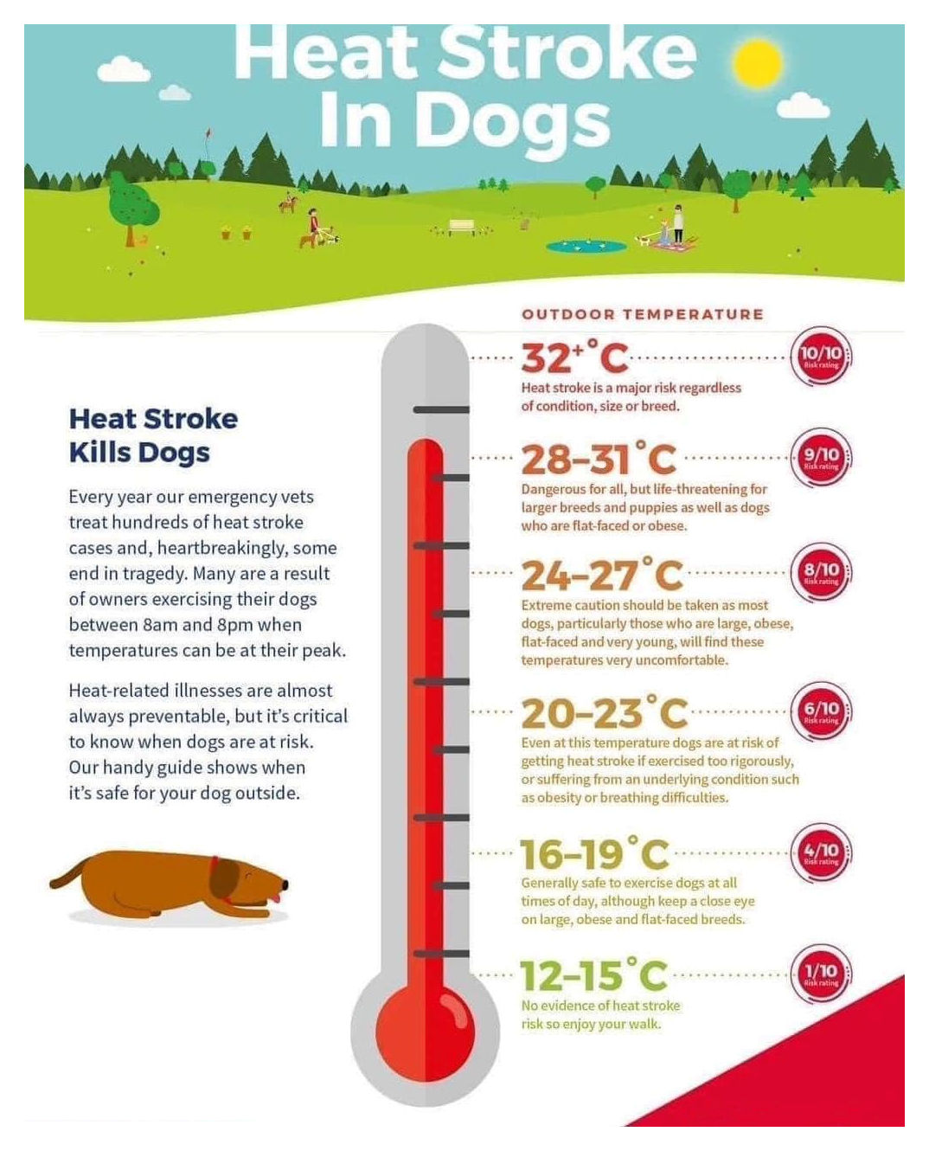

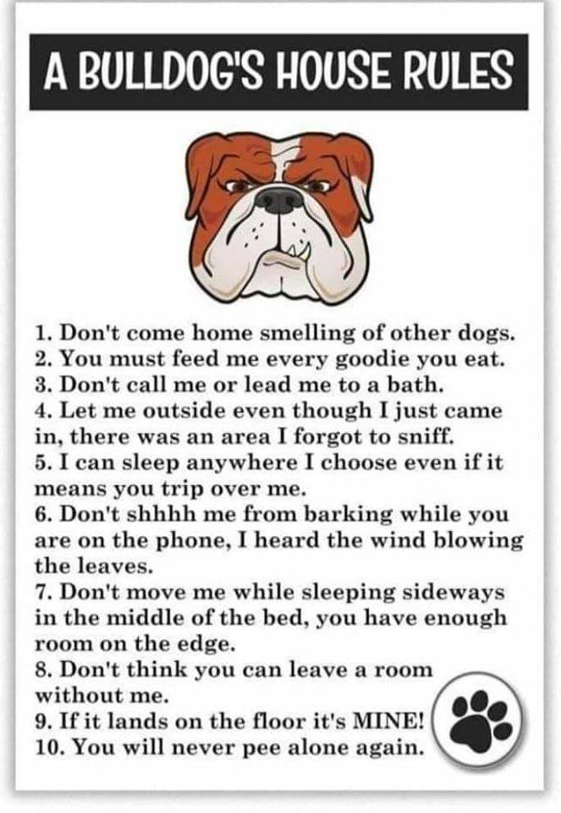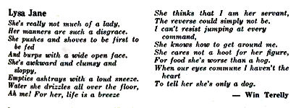

**Hope you all had a wonderful Christmas, and a safe and Happy New Year**



**Stud & Advertisers List**

|  |  |
| --- | --- |
| **BRATRICE BRITISH BULLDOGS** Mrs Sharon Phegan P. O. Box 710 Toukley, NSW, 2263 Ph. 0414-729-809 E: bratricebulldogs@bigpond.com #2000782790 | **BUBBASBEST BRITISH BULLDOGS**  Mario & Katar Pace 68 Samuel Marsden Road Orchard Hills 2748 P: 0413-212-041 E: pacebulldogs@hotmail.com #2100039210 |
| **BULDAWG BRITISH BULLDOGS**  Robert & Carla Smith Jean Street,  Greenacre, 2190 P: 02-9642-7142 E: buldawg@bigpond.net.au #2000256150 | **BULLMAJESTY KENNELS**  Courtney & Hayden Smith P. O. Box 7291 Mount Annan, 2567 P: 0406-928-105 E: courtney.smith@gmail.com #2100075303 |
| **BUMBULLB BRITISH BULLDOGS**  Donna Whillock Bargo 2574 P: 0409-966-372 E: donna.whillock22@gmail.com #2100016325 | **DELITEABULL BRITISH BULLDOGS**  Heath & Tracey Smith P. O. Box 3. Warragamba NSW 2752 P: 0411-882-007 E: deliteabull@gmail.com #2100064923 |
| **KARSLEMAINE BRITISH BULLDOGS**  Cindy Elliott Vidler Court Landsborough Qld 4550 P: 0467-081-516 E: karslemaine@hotmail.com #4004591840 | **KARMABULLZ BRITISH BULLDOG**  Toni Whillock Bargo 2574 P: 0437-763-380 E: karmabullz.2571@gmail.com #2100072976 |
| **KOARRA BRITISH BULLDOGS**  Sue Daley 596 Creek Ridge  Freemans Reach 2756 P: 024579-6503 #2100022840 | **LLEMMEGS BRITISH BULLDOGS**  John & Liane Gemmell 61 Gerald Road Illawong 2234 P: 02-9543-4779 E: llemmegs@optusnet.com.au #2000687650 |
| **MUSCENNY BRITISH BULLDOGS**  Chris & Ann Rees 6 Grevillia Ave Davistown, 2251 P: 02-4369-1560 #2000818460 E: muscennydogschris@gmail.com #2100067387 | **$10 to have your add here** |
| **PROVOST BRITISH BULLDOGS**   Allison Lang Lower Kangaroo Creek Rd Coutts Crossing, 2460 P: 0419-261-689  E: provostbulldogs@gmail.com #2000729310 | **SAWYERMOON KENNELS**  Susan Dellas Faulconbridge 2776 P: 02-4751-7312 E: barbarag@bigpond.net.au #2100033973 |
| **WONDERBULL BRITISH BULLDOGS**  Vince & Wanda Henebery P.O. Box 196 Culburra Beach NSW 2540 P: 0412-731-372 E: vincewanda@bigpond.com #2000257560 | **NEVILLEBULL KENNELS**  Marion Greentree 1 Carcoar Street Neville NSW 2799 P: 0433-644-172 E: nevillebullbulldogs@gmail.com #2100090149 |
| **DISCLAIMER The Breeders who appear throughout this magazine and or web-site are merely breeders that The British Bulldog Club of NSW Inc. understands may have litters for sale. In providing you with their details The British Bulldog Club of NSW Inc. makes no representations as to the reputation of any breeder or as to the soundness or suitability of any puppy you may decide to acquire from any breeder. You must satisfy yourself that any puppy you may decide to acquire is healthy, sound and meets your requirements. The B. B. C. of NSW Inc. accepts no responsibility in respect of the information contained in its magazine and or web-site in respect of any puppy that you may decide to acquire from any breeder in it. Any personal disputes between members/buyers are a private or domestic nature and do not involve The B.B. C. of NSW Inc. and should be properly resolved by the courts or the Dept. of Fair Trading. All breeders who are current members of Dogs NSW have agreed to abide by the Dogs NSW rules** | |

