**Championship Show**

**SPONSORED BY ROYAL CANIN**

**September 12th 2020**

**Judge Mr John Sheppard (NSW)**

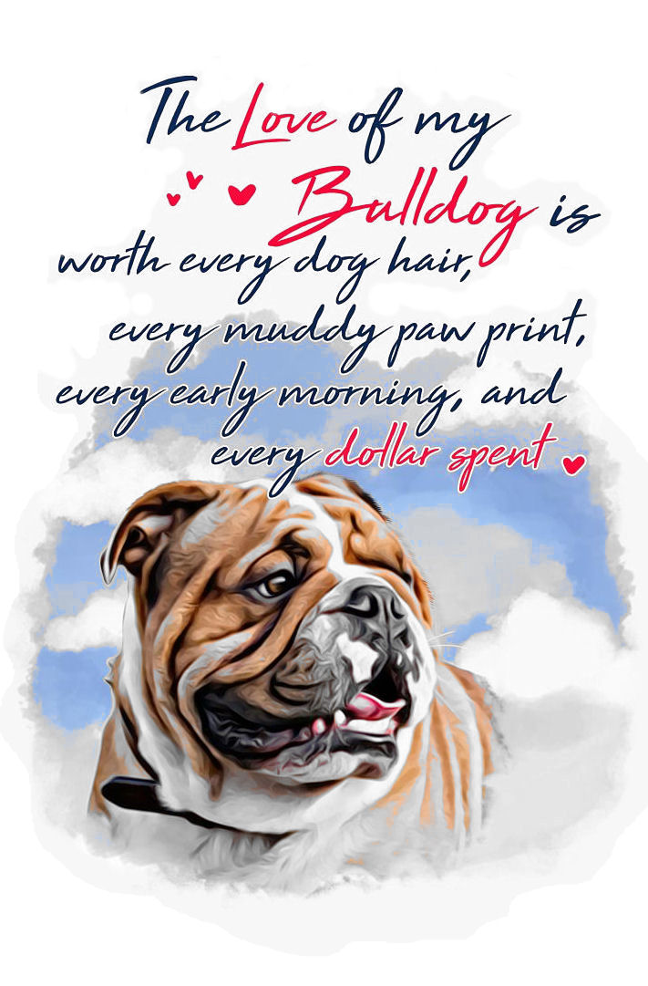

**The British Bulldog Club of NSW Inc.**

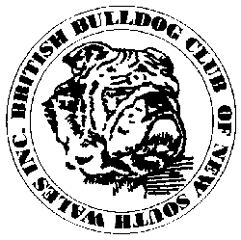

***Executive & Committee***

*President*: Mr Chris Small *Hon. Secretary:* Mrs Ann Small

*Treasurer:* Mrs Tracey Smith *Assist. Secretary:* Mrs Courtney Smith

*Senior Vice President: Mrs Susan Dellas*  *Junior Vice President*: Mr Hayden Smith

***Committee:*** Mrs Narelle Darragh, Mrs Denise Daniels, Mr Heath Smith, Mr Mario Pace,

Mrs Courtney Smith, Mr Robert Smith, Mrs Lisa Snow

***Publicity Officer:*** Mrs Carla Smith

***Show Manager:***Mr Chris Small ***Assistant Show Manager:*** Mr Hayden Smith

***Trophy Steward:*** Mrs Courtney Smith ***Assistant Trophy Steward***: Mrs Tracey Smith

***Life Patrons*** Mr John Gemmell ***Life Patroness:*** Mrs Jennifer Prien

***Life Members:***

Mr J Gemmell Mr M Gooi Mrs J Penny Mrs J Prien   
 Mrs D Roberts Mr P Roberts Mrs C Smith Mr W Stacey (dec.)

**We would like to welcome our Judge today, hope he enjoys our breed and   
 our breeders.**

**OUR JUDGE TODAY ....................... Mr John Sheppard (NSW)**

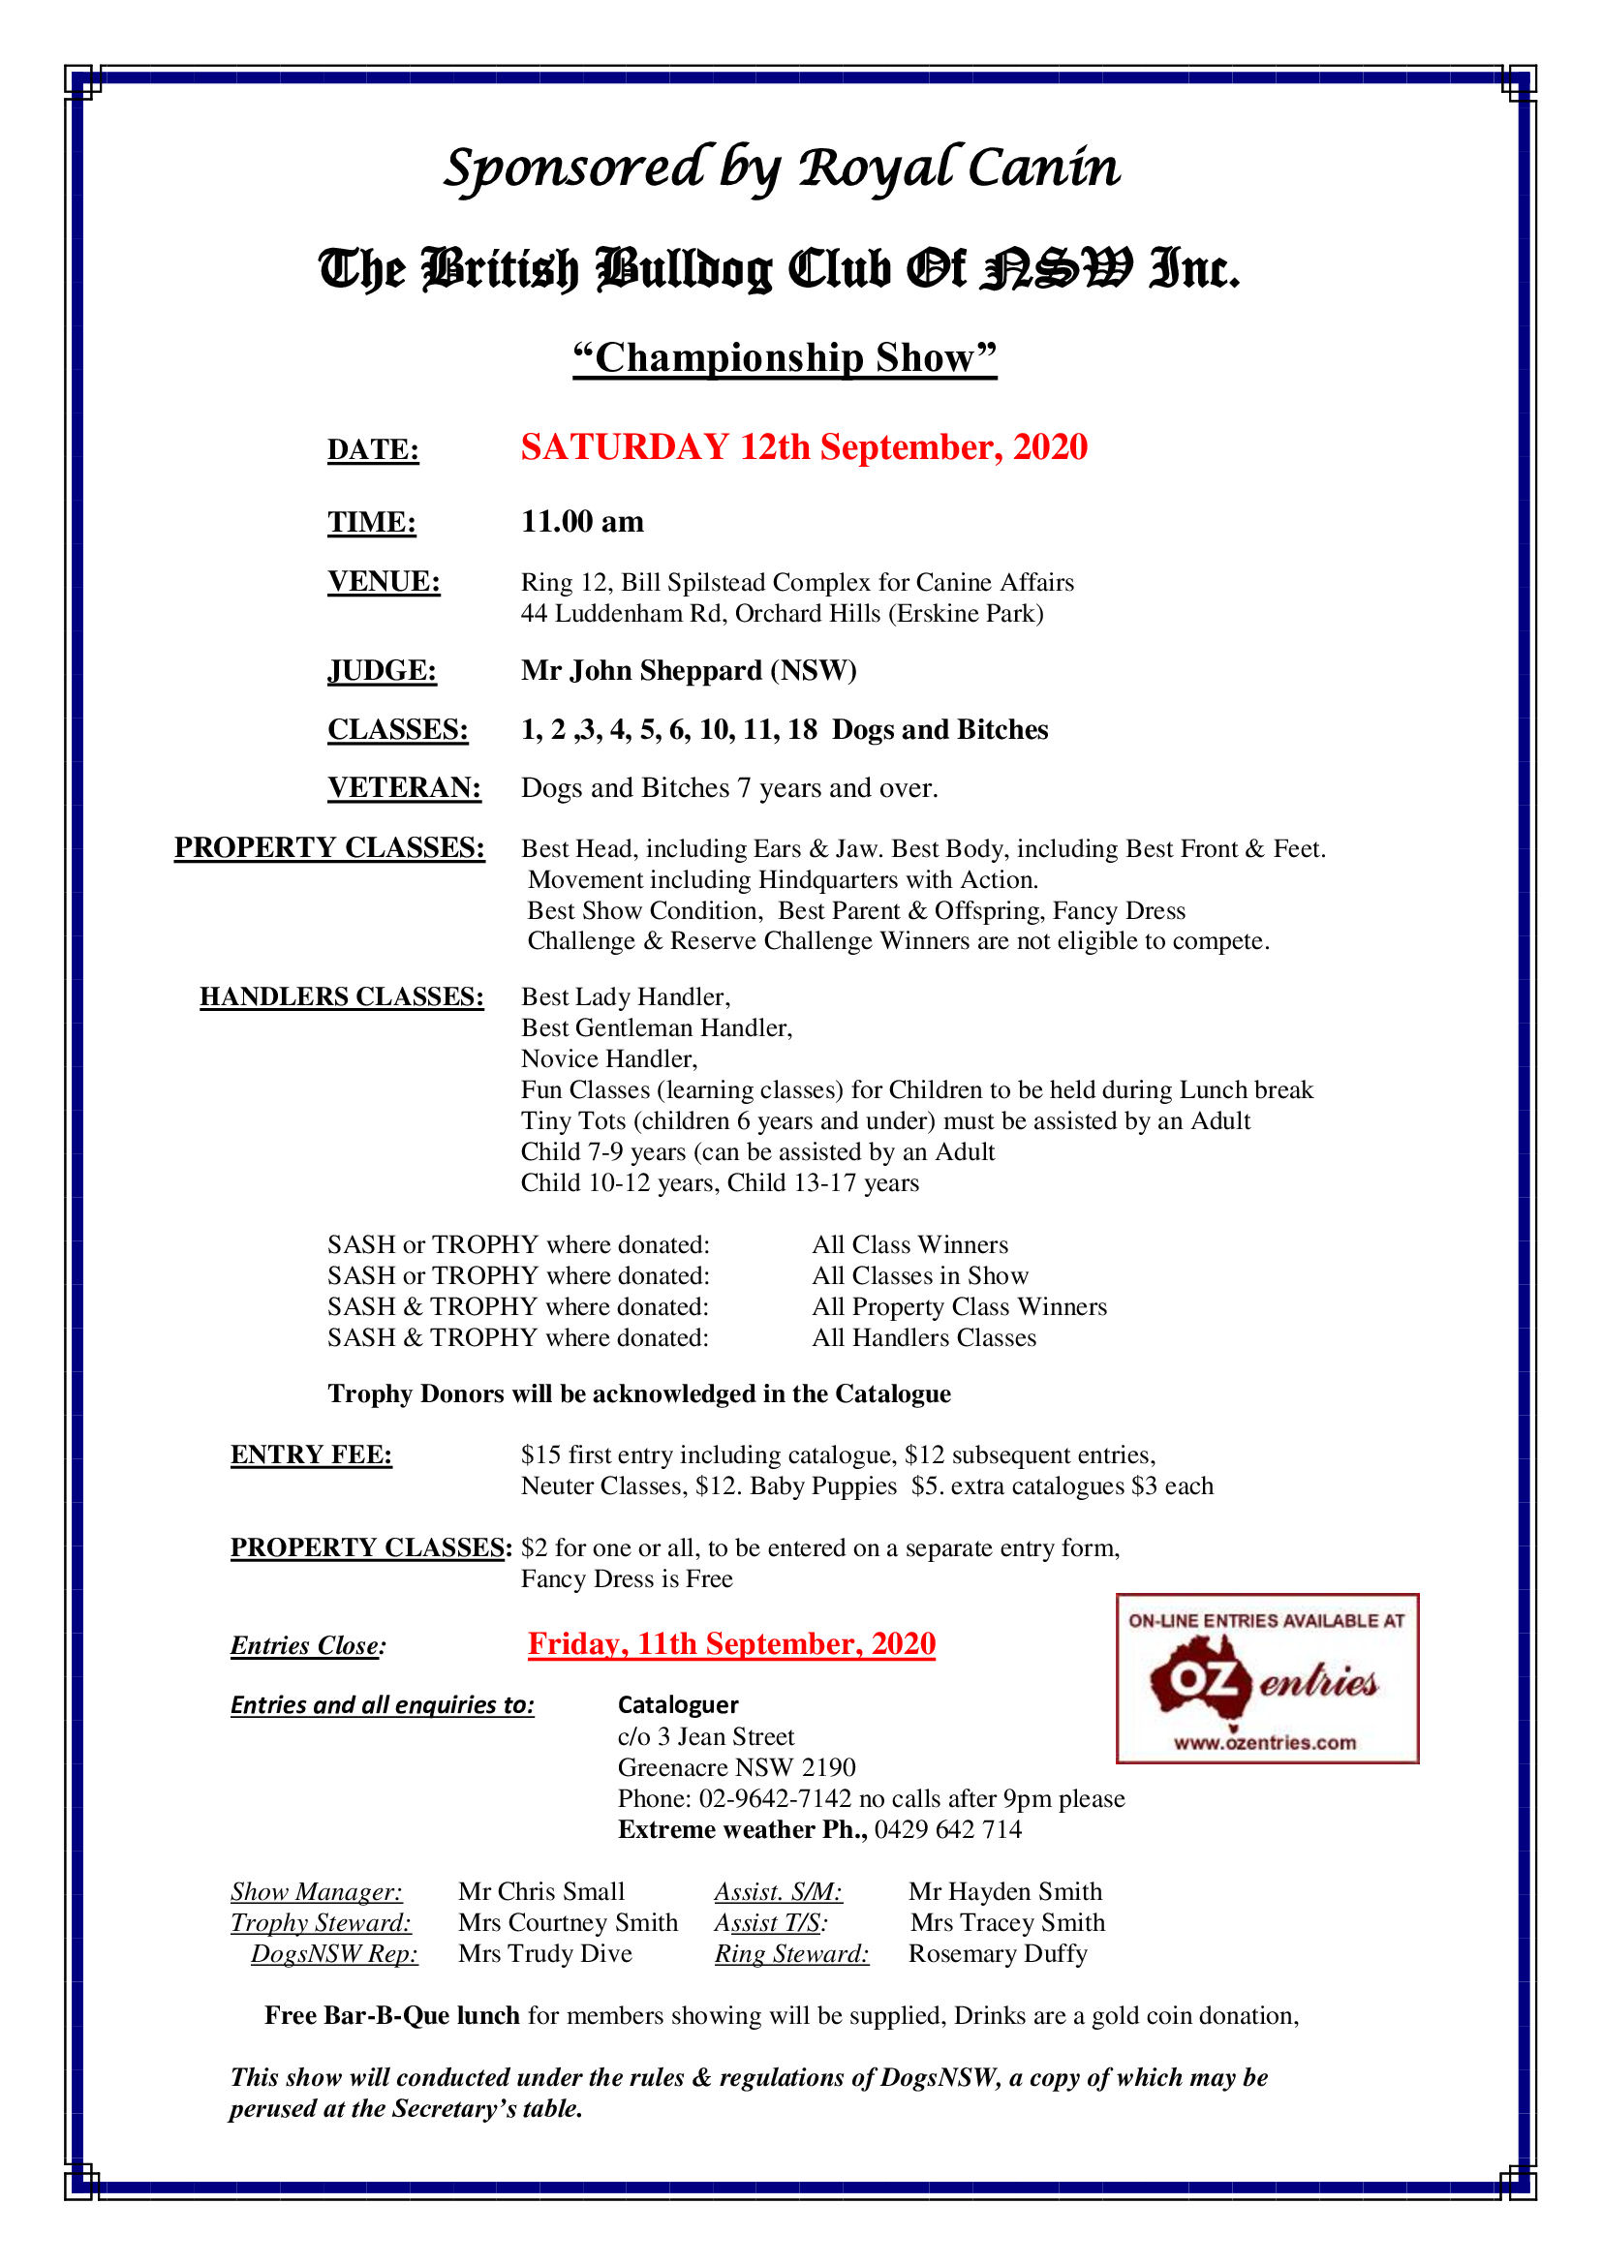

**TROPHY DONORS ACKNOWLEDGEMENT**

**The British Bulldog Club of NSW Inc. would like to thank the following   
people for their kind donations to our Championship Show  
  
THANK YOU!**

**Royal Canin   
  
Orivet Genetic Pet Care $175 DNA vouchers**

**British Bulldog Club of NSW**

**Courtney & Hayden Smith**

**Ann & Chris Small**

**Best in Show – Llemmegs**

**Runner up in Show – Narelle Darragh**

**Challenge Dog – Al’s Tree Services**

**Challenge Bitch – Wonderbull British Bulldogs**

**Minor Puppy in Show - Kicklaack British Bulldogs**

**Opposite Minor Puppy in Show - Kicklaack British Bulldogs**

**Puppy in Show – Athalow Kennels**

**Opposite Puppy in Show – Athalow Kennels**

**Junior in Show - Omana British Bulldogs**

**Opposite Junior in Show – Delitabull British Bulldogs**

**Intermediate in Show - Re-do Kitchens**

**Opposite Junior in Show – Delitabull British Bulldogs**

**Aust Bred in Show - Omana British Bulldogs**

**Opposite Aust Bred in Show – AVAE British Bulldogs**

**Open in show $25 - Ichellemay Kennels**

**Veteran in show $25 - Robocky British Bulldogs**

**Junior Handlers – AVAE British Bulldogs**

|  |  |  |
| --- | --- | --- |
| **Class 2**  **Minor Puppy Dog** | | **Entries 1** |
|  | | |
| **1** | G Edmunds & C & H Smith | **BRITISHEXTRA THE IRISHMAN (AI)**  2100544050 DOB 2/3/20  Sire: Uk Ch. Gongar King Henry Bulls (impIrl)  Dam: Britishextra All Class  Breeder: Exh. |
| First ........1......... | | |
| **Class 3**  **Puppy Dog** | | **Entries 2** |
| **2** | G Edmunds & C & H Smith | **BRITISHEXTRA THE KINGSMAN (AI)**  2100544051 DOB 2/3/20  Sire: Uk Ch. Gongar King Henry Bulls (impIrl)  Dam: Britishextra All Class  Breeder: Exh. |
| **3** | P Roberts & K Trueman | **TRUWINKS GAMBLING MAN**  2100536845 DOB 8/2/20  Sire: Ch Embolden Rule Breaker  Dam: Ch Hefty Ramblin Rose  Breeder: K Trueman |
| First ......2....... Second ......3........ | | |
| **Class 4**  **Junior Dog** | | **Entries 2** |
| **4**  **A** | Alison & Robert Lang | **PROVOST THE OLD PRETENDER**  2500525096 DOB 19/8/19  Sire: Bubbasbest Wild Willy  Dam: Ch Provost Prudence  Breeder: Exh. |
| **5** | Alison McGuire | **IRONBULL PANDA FEARLESS**  2100528570 DOB 9/9/19  Sire: Ch Llemmegs Sherman Tank  Dam: Eshad McGuire  Breeder: Exh. |
| First .....5..... Second .......... | | |

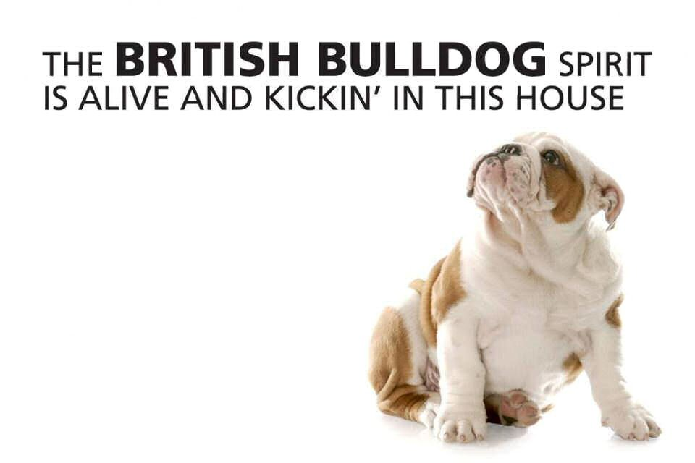

|  |  |  |
| --- | --- | --- |
| **Class 10**  **Australian Bred Dog** | | **Entries 3** |
| **6** | Susan Dellas | **SAWYERMOON ALADDIN (AI)**  2100524857 DOB 20/7/19  Sire: Ndl. Ch Testwood Tom (impUK)  Dam: Provost Isleiona  Breeder: Exh. |
| **7** | Mario Pace | **BUBBASBEST WILD WILLY**  2100039210 DOB 10/6/18  Sire: Ch Provost The Young Pretender  Dam: BBBull Jay Jay  Breeder: Exh. |
| **8** | N Spencer & V Philip | **CH HEFTY GAME CHANGER**  2100485433 DOB 19/10/17  Sire: Llemmegs Hobtop Gold Nugget (ai)  Dam: Ch Hefty Just A Joy  Breeder: Exh. |
| First .....7..... Second ....8..... Third ....6...... | | |
| **Class 11**  **Open Dog** | | **Entries 3** |
| **9**  **A** | J P Gemmell | **CH LLEMMEGS SHERMAN TANK**  2100439348 DOB 6/10/15  Sire: Truwinks Prince Fredrick (ai)  Dam: Embolden All About Eevee  Breeder: Exh. |
| **10** | Rod Lang | **PRINCIBULL DONT UNO IT**  2100485739 DOB 19/10/17  Sire: Ch BumbullB Princibul Big Dog Uno  Dam: Ch BumbullB Roxy Ruble  Breeder: Exh. |
| **11** | Courtney & Hayden Smith | **SRB CH MAUMI WALTHER (imp SRB)**  J474320 DOB 2/7/17  Sire: Rom Jr Ch Mne Jr Ch Home Pilar Kilombo (SRB)  Dam: Mne Ch Mac Ch Maumi History (SRB)  Breeder: Ivana Brdarevic |
| First ....10...... Second ....11..... Third .......... | | |
| **CHALLENGE DOG .........7..........**  **RESERVE CHALL DOG .........1................** | | |
| **Class 3a**  **Puppy Bitch** | | **Entries 1** |
| **12** | N Spencer & V. Philip | **KOARRA BURLESQUE BABY**  2100530907 DOB 21/11/19  Sire: Hefty Widow Maker  Dam: Koarra Miss Izzy (ai)  Breeder: S & S Daley |
| **First ....12.....** | | |
| **Class 4a**  **Junior Bitch** | | **Entries 1** |
| **13** | Susan Dellas | **SAWYERMOON GOLDILOCKS (Ai)**  2100524858 DOB 20/7/19  Sire: Ndl Ch Testwood Tom (impUK)  Dam: Provost Isleiona  Breeder: Exh |
| First ....13..... | | |
| **Class 5a**  **Intermediate Bitch** | | **Entries 1** |
| **14** | Courtney & Hayden Smith | **DELITEABULL DO THE FLOSS**  2100075303 DOB 25/5/18  Sire: Elhanan Puff En Stuff  Dam: Snailsbury Misty Morning  Breeder: T Smith |
| First ...14...... | | |
| **Class 10a**  **Australian Bred Bitch** | | **Entries 2** |
| **15** | N Spencer & V Philip | **CH HEFTY JUSTA JOY**  210039861 DOB 24/8/13  Sire: Ch Bratrice Natural Justice  Dam: Hefty Deck The Halls  Breeder: Exh. |
| **16** | Courtney & Hayden Smith | **CH BRATRICE BREAKING THE ICE**  2100481238 DOB 26/8/17  Sire: Sealaville He’s Bruce (impUK)  Dam: Bratrice In My Own Sweet Time  Breeder: Sharon Edmunds |
| First ...16....... Second ....15...... | | |

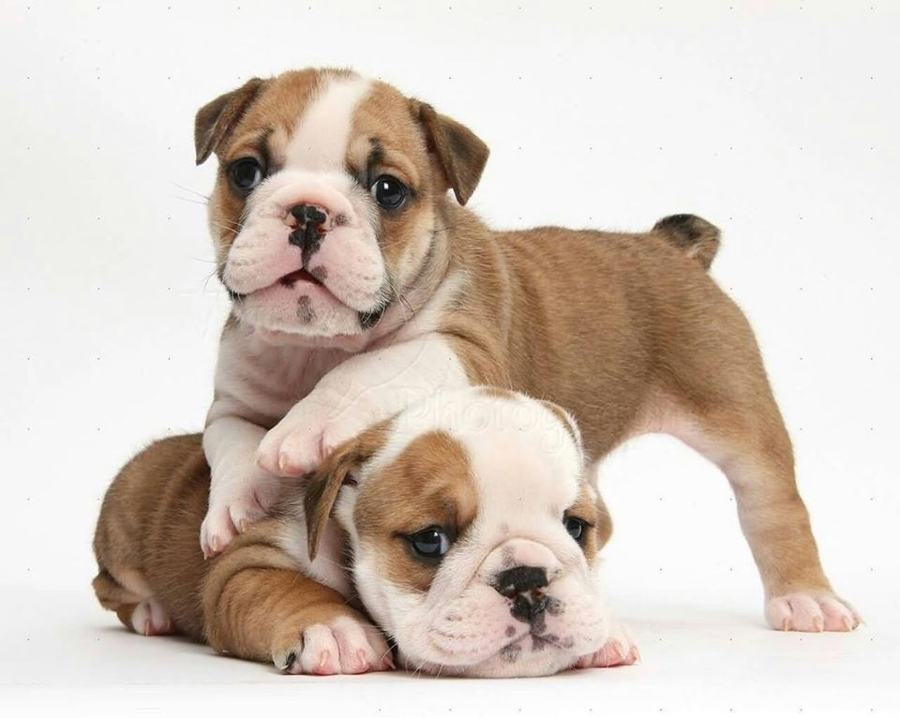

|  |  |  |  |
| --- | --- | --- | --- |
| **Class 11a**  **Open Bitch** | | | **Entries 4** |
| **17**  **A** | J P Gemmell | | **CH THISTLEBULL I LOVE LUCY**  2100429259 DOB 11/5/15  Sire: Truwinks Prince Fredrick (ai)  Dam: Thistlebull Pom The Princess  Breeder: Mrs A Walker |
| **18**  **A** | A & R Lang | | **PROVOST PRUDENCE**  2100409481 DOB 26/6/14  Sire: Provost Crixus  Dam: Provost Softail Classic  Breeder: Exh. |
| **19** | Rod Lang | | **BRATRICE JUSTIFY**  2100467212 DOB  Sire: Ch Bratrice Natural Justice  Dam: Bratrice In My Own Sweet Time  Breeder: Sharon Edmunds |
| **20** | Ken Trueman | | **CH HEFTY RAMBLING ROSE**  2100485436 DOB 19/10/17  Sire: Llemmegs Hobtop Gold Nugget (ai)  Dam: Ch Hefty Just Joy  Breeder: N Spencer & V Philip |
| First ....20...... Second ...19...... Third .......... | | | |
| **CHALLENGE BITCH ..........20.............**  **RESERVE CHALL BITCH...........14.....................** | | | |
| **BEST IN SHOW**  **..............20................**  **RUNNER UP BEST IN SHOW**  **..............14................** | | | |
| **CLASS 12**  **VETERAN BITCH** | | | **Entries 1** |
| **15** | N Spencer & V Philip | | **CH HEFTY JUSTA JOY**  210039861 DOB 24/8/13  Sire: Ch Bratrice Natural Justice  Dam: Hefty Deck The Halls  Breeder: Exh. |
| **First .........15.............**  **Best Veteran .....15..........** | | | |
| **PROPERTY CLASSES PREPAID** | | | |
| |  | | --- | | SAWYERMOON GOLDILOCKS (AI) | | SAWYERMOON ALADDIN. (AI) | | PROVOST THE OLD PRETENDER | | PROVOST PRUDENCE | | BRITISHEXTRA THE IRISHMAN (AI) | | BUBBASBEST WILD WILLY | | CH HEFTY GAME CHANGER | | DELITEABULL DO THE FLOSS | | IRONBULL PANDA FEARLESS | | | | |
| **Dogs No** | | **PROPERTY CLASSES** | |
| **11** | | Best Head, including ears & jaw | |
| **7** | | Best Body, including front & feet | |
| **7** | | Best Movement, including hindquarters with action | |
| **7** | | Best Show Condition | |
| **--------** | | Best of Parent & Offspring | |
|  | | | |
|  | **HANDLERS CLASSES** | | |
|  | Best Lady Handler | | Best Gentleman Handler |
|  | Novice Handler | | Fancy Dress |
|  | Fun Classes (learning classes) for children to be held during lunch break | | |
|  | Tiny Tots, (children 6 years and under must be assisted by an Adult | | Child 7 to 9 years  Can be assisted by and Adult |
|  | Child 10 to 12 years | | Child 13 to 17 years |
|  | | | |
| **TROPHIES** | | | |
| SASH or TROPHY where donated | | | All Class Winners |
| SASH or TROPHY where donated | | | All Classes in Show |
| SASH or TROPHY where donated | | | All Property Class Winners |
| SASH or TROPHY where donated | | | All Handlers Classes |
| **Trophy Donors will be acknowledged in the Catalogue** | | | |



General Specials

September 12th 2020

|  |  |  |  |  |  |  |  |
| --- | --- | --- | --- | --- | --- | --- | --- |
| Best in Show | 20 | | Runner Up Best in Show | | | | 14 |
| Baby Puppy in Show | N/A | | Opposite Baby Puppy in Show | | | | N/A |
| Minor Puppy in Show | 1 | | Opp. Minor Puppy in Show | | | | N/A |
| Puppy in Show | 12 | | Opp. Puppy in Show | | | | 2 |
| Junior in Show | 5 | | Opp Junior in Show | | | | 13 |
| Intermediate in Show | 14 | | Opp. Intermediate in Show | | | | N/A |
| Aust. Bred in Show | 7 | | Opp. Aust. Bred in Show | | | | 16 |
| Open in Show | 20 | | Opp. Open in Show | | | | 10 |
| Challenge Dog | 7 | | Reserve Challenge Dog | | | | 1 |
| Challenge Bitch | 20 | | Reserve Challenge Bitch | | | | 14 |
| Best Veteran | 15 | | Opp. Veteran | | | | N/A |
| Best Neuter | N/A | | Opp Neuter | | | | N/A |
| **Property Classes** | | | | | | | |
| Best Head including Ears & Jaw | | | | | 11 SRB Ch Maumi Walther | | |
| Best Body including Front & Feet  Best Movement including Hindquarters with Action | | | | | 7 Bubbasbest Wild Willy | | |
| 7 Bubbasbest Wild Willy | | |
| Best Show Condition Parent & Offspring | | | | | 7 Bubbasbest Wild Willy | | |
| Nil | | |
| Fancy Dress | | | | | 5 Ironbull Panda Fearless | | |
| **Handler Classes** | | | | | | | |
| Gentleman Handler | | Lyndsay Kruse | | Lady Handler | | Nil | |
| Novice Handler | | Nil | |  | |  | |
| Tiny Tots Fun class | | Brody Smith, Patyn & Wyatt Parrish | | Child Handler 7-9 | | Izzac Pace | |
| Child Handler 10-12 | | Isabel McGuire | | Child Handler 13-17 | | Nil | |

**STUD & KENNEL ADVERTISERS PAGE**

|  |  |
| --- | --- |
| **BEIZERBULI BULLDOGS**  *Ms Kerry Dunne 29a Phyllis Street*  *Mt Pritchard 2170*  *M: 0422-815-986 #2000798580* | **BRATRICE BRITISH BULLDOGS**  *Breed information  & Puppy enquires welcome* ***At Stud: Ch Bratrice Deal Breaker***  *Sharon Edmunds 4 Watt Street*  *Windermere Park 2264*  *M: 0414-729-809 e-mail bratrice@bigpond.com #2000782790* |
| **BULDAWG BRITISH BULLDOGS**  *Robert & Carla Smith*  *Breed information  & Puppy enquires welcome*  *Jean Street*  *Greenacre 2190 Ph: 02-9642-7142 E: buldawg@bigpond.net.au #2000256150* | **BULDOK BRITISH BULLDOGS**  ***At Stud:*** *Ch Buldok Our Sampson Buldok Omeley  Ch Buldok Buff Ch Buldok Boris*  *Wayne & Shane Cooper*  *22 Maud Street*  *Cardiff South 2285 P: 4954-7439*  *E: amandacooper@optusnet.com.au* #2100027626 |
| **BUMBULLB BRITISH BULLDOGS**  ***At Stud to Approved bitches:***  *Ch BumbullB Redfred  Grd Ch Janayin Who Wears Da Pants  Ch Bumbullb Withya Pantz Down*  *Donna Whillock*  *Picton, NSW*  *M: 0409-966-372*  *E: donna.whillock22@gmail.com #2100016325* | **EMBOLDEN BULLDOGS**  ***At Stud to Approved bitches*** *Ch Embolden Rule Breaker  Ch Embolden Right Said Fred Ch Ocobo Red Sunset (impUK)*  *Rick & Narelle Taylor*  *Thirroul NSW*  *M: 0406-431-578 E: emboldenbulldogs@bigpond.com #2006981220* |
| **GEEKAY BRITISH BULLDOGS**  *Puppies sometimes available enquires welcome*  *Gavin & Katrina Parker*  *Lurnea, NSW 2170*  *M: 0414-264-219*  *E: g.j.parker@optusnet.com.au #2100071515* | **GODLLUBEM BRITISH BULLDOGS**  *Deborah Drysdale Puppies sometimes available*  *Liverpool 2170*  *M: 0432-277-293 E: deborah_drysdale@hotmail.com #2100041328* |
| **HEFTY BRITISH BULLDOGS**  *Breed information, stud & puppy enquires welcome puppies sometimes available*  *Narelle Spencer & Val Philip*  *P: 02-9543-4079*  *E: n.spencer@exemail.com.au #2100343312* | **KARSLEMAINE BRITISH BULLDOGS**  *breed information, stud &  puppy enquiry’s welcome* ***at stud****: Ch Karslemaine Kassius Klay Ch Wonderbull Ali B Back*  *Cindy Elliott*  *Vidler Court*  *Landsborough, 4550*  *M: 0467-081-516*  *E: karslemaine@hotmail.com #4004591840* |
| **KOARRA BRITISH BULLDOGS**  *Breed information, stud & puppy enquires welcome*  *Sue Daley*  *596 Creak Ridge*  *Freemans Reach 2756 P: 02-4579-6503 #2100022840* | **LLEMMEGS BRITISH BULLDOG**  *John & Liane Gemmell*  *Breed information, stud & puppy enquires welcome*  *61 Gerald Road*  *Illawong, 2234*  *P: 02-9543-4779*  *E: llemmegs@optusnet.com.au #2000687650* |
| **MUSCENNY BRITISH BULLDOG**  *Breed information, stud & puppy enquires welcome*  *Anne & Chris Rees*  *6 Grevillia Ave*  *Davistown 2251*  *P: 02-4369-1650 #2000818460  E: muscennydogschris@gmail.com #2100067387* | **PROVOST BRITISH BULLDOGS**  *Robert & Allison Lang*  *Breed information, stud & puppy enquires welcome*  *The Ironbarks*  *Picton 2566 M: 0419-261-689*  *E:* [*provostbulldogs@gmail.com*](mailto:provostbulldogs@gmail.com) *#2000729310* |
| **SAWYERMOON KENNELS**  *At stud to approved bitches Ch Sawyermoon Lord Grantley*  *Susan Dellas*  *Faulconbridge 2776*  *02-4751-7312*  *E: barbarag@bigpond.net.au #2100033973* | **WONDERBULL BRITISH BULLDOGS**  *Vince & Wanda Henebery*  *Breed information, stud & puppy enquires welcome*  *P.O. Box 196*  *Culburra Beach NSW 2540*  *P: 0412-731-372 E: vincewanda@bigpond.com #2000257560* |
| **BULLMAJESTY KENNELS**  *Courtney & Hayden Smith P.O. Box 7291 Mount Annan 2567 M: 0406-291-805 E: courtney@terracivil.com.au #2100075303*  *Breed information puppies sometimes available* | DISCLAIMER The Breeders who appear throughout this magazine and or web-site are merely breeders that The British Bulldog Club of NSW Inc. understands may have litters for sale. In providing you with their details The British Bulldog Club of NSW Inc. makes no representations as to the reputation of any breeder or as to the soundness or suitability of any puppy you may decide to acquire from any breeder. You must satisfy yourself that any puppy you may decide to acquire is healthy, sound and meets your requirements. The B. B. C. of NSW Inc. accepts no responsibility in respect of the information contained in its magazine and or web-site in respect of any puppy that you may decide to acquire from any breeder in it. Any personal disputes between members/buyers are a private or domestic nature and do not involve The B.B. C. of NSW Inc. and should be properly resolved by the courts or the Department of Fair Trading All breeders who are current members of Dogs NSW have agreed to abide by the Dogs NSW Regulations, including the Code of Ethics. |

