**Championship Shows no 1 & 2.**



**April 2nd 2023**

**Celebrating the Life Of  
Diane Roberts   
Judge Mr Rory Lowe (NZ)**

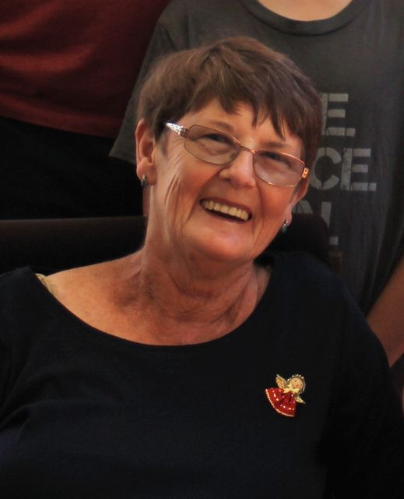**The British Bulldog Club of NSW Inc.**

***Executive:***

*President*: Mr Chris Small *Hon. Secretary:* Mrs Ann Small

*Treasurer:* Mrs Tracey Smith *Assist. Secretary:* Mrs Courtney Smith

*Senior Vice President:* Mrs Susan Dellas *Junior Vice President*: Mr Hayden Smith

***Committee:*** Narelle Darragh, Mrs Denise Daniels, Mr Heath Smith, Mr Mario Pace,

Mrs Courtney Smith, Mr Robert Smith, Mr Brett Grant

***Publicity Officer:*** Mrs Carla Smith

***Show Manager:***Mr Chris Small ***Assistant Show Manager:*** Mr Hayden Smith

***Trophy Steward:*** Mrs Courtney Smith ***Assistant Trophy Steward***: Mrs Tracey Smith

***Life Patrons*** Mr Bruce Palmer (dec.) ***Life Patroness:*** Mrs Jennifer Prien (dec.)

Mr John Gemmell

***Life Members:*** Mr J Gemmell Mr M Gooi Mrs J Penny Mrs J Prien (dec)   
 Mrs D Roberts (dec) Mr P Roberts Mrs C Smith Mr W Stacey (dec.)

Mrs A. Small

**We would like to welcome our Judge today.**

**We hope he enjoys our breed and our breeders.**

**OUR JUDGE Show 1 ................ Mr Rory Lowe (NZ)**



**The British Bulldog Club Of NSW Inc.**

**A DOUBLE CHAMPIONSHIP SHOW  
Celebrating the Life of Di Roberts**

**DATE:** Sunday 2nd April 2023 **VENUE:** Penrith Anglican Collage   
 338-356 Wentworth Road, Orchard Hills

**CLASSES:** 1, 2, 3, 4, 5, 8, 10, 11, 18, Dogs and Bitches **VETERAN:** Dogs and Bitches 7 years and over.  
**PROPERTY CLASSES:** Best Head, including Ears & Jaw, Best Body including Best Front & feet, Best   
 Movement including Hindquarters with Action. Best Show Condition,   
 Best Parent & Offspring, Easter Bonnet

**HANDLERS CLASSES:** Best Lady Handler, Best Gentleman Handler, Best Novice Handler, Jnr. Handlers  
 **SHOW 1**

**TIME:** 10am

**JUDGE:** Mr Rory Lowe (NZ) steward Mary Anki Keler **PROPERTY & HANDLER CLASSES**

**TIME:** During the Lunch Break, not before 12pm

**JUDGE:** Mrs Carla Parr (NSW) Trainee Judge

**SHOW 2**

**TIME:** Not before 1PM at the conclusion of property classes,

**JUDGE:** Mr Aaron Scott Go (Philippines) steward Elizabeth Vassello

SASH or TROPHY: All Class Winners,   
SASH or TROPHY: All Property Class Winners,   
SASH or TROPHY: All Handlers Class Winners

**Trophy Donors will be acknowledged in the Catalogue**

**ENTRY FEE:** $15 first entry including catalogue, $12 subsequent entries,  
Neuter Classes, $12. Baby Puppies $5, extra catalogues $3 each,   
$2 Property Classes for one or all, Easter Bonnet is Free

**ENTRIES CLOSE: *Monday 27th March 2023***

**ENTRIES & ENQUIRIES TO*:*  Cataloguer**3 Jean Street, Greenacre NSW 2190  
Phone: 02-9642-7142 no calls after 9pm please  
**Extreme weather Ph.,** 0429-642-714

*Show Manager:* Mr Chris Small *Assist. S/M:* Mr Hayden Smith  
*Trophy Steward:* Mrs Courtney Smith *Assist T/S:* Mrs Tracey Smith *DogsNSW Rep:* Mrs Trudy Dive *Ring Steward:* Mary Ann Keller, Elizabeth Vasello

**Free Bar-B-Que lunch** for members showing will be supplied, Drinks are a gold coin donation,  *\*This show will conducted under the rules & regulations of DogsNSW, a copy of which may be perused at the Secretary’s table\**

Celebrating the Life of Di Roberts  
Life Member BBCNSW

Firstly, let me say that it is indeed an honour to Di and myself for the Club to hold a Day of Celebrating the Life of Dianne known to everybody as Di. I’m sorry I am not bringing a “trifle” in her memory.

Di loved the British Bulldog Club of NSW and in days gone by worked very hard for this Club. Di was given, together with myself, Life Membership of the Club in 2000, which she was very honoured and proud to receive.

We bred under the prefix “Westhill” and although we weren’t prolific breeders as our work did not give us the time to devote to the whelping and rearing of pups, the litters we did breed were gratefully raised by wonderful bulldoggers such as Dulcie Partridge, (Kama) Lil and Beryl Robinson, (Avonmist) and Jean Turton (Chajen). To these ladies thank you.

The prefix Westhill was owned by Matron I Butler and established in 1945, and the RNSWCC allowed us to transfer the prefix into our names in her memory.

This was to be Di’s first exploration into the world of Bulldogs. My friend, Matron Butler, was seriously ill in hospital and in 1973 asked me to take care of her last Bulldog. This meant going to Otford near Stanwell Park to pick Tania up. Unbeknownst to me Di was terrified. I told her it would all be OK, Tania will just sit at her feet in the car. Di knew she would be eaten before we got home with this Bulldog devouring her in the car. One hundred kilometres later, before we got home, Di had been converted to the love of Bulldogs.

We met some wonderful people in our times of showing, showing was a relaxation after our very demanding employments. Di became very knowledgeable, soaking up every detail from the Bulldoggers of yesteryear and was a point of reference in later years.

Thank you to all those people remembering Di Roberts today.

Kindest regards and my sincerest thanks,  
Phil Roberts and the Roberts family.

 

**THE BRITISH BULLDOG CLUB OF NSW INC.**

**WISHES TO THANK**

**ROYAL CANIN**

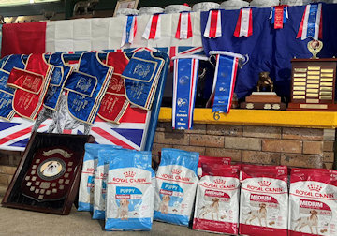**FOR THEIR GENEROUS SPONSORSHIP**

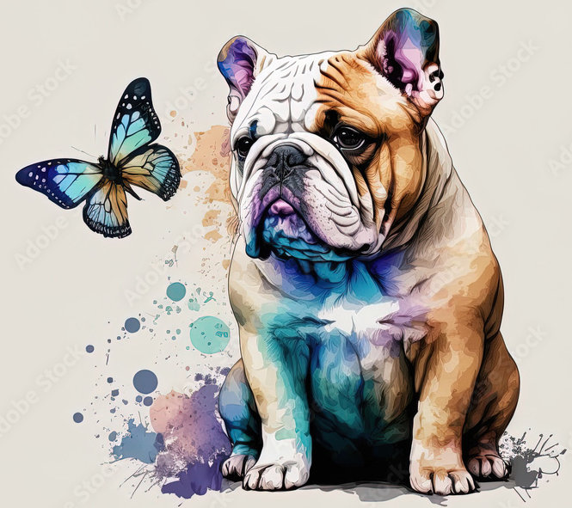

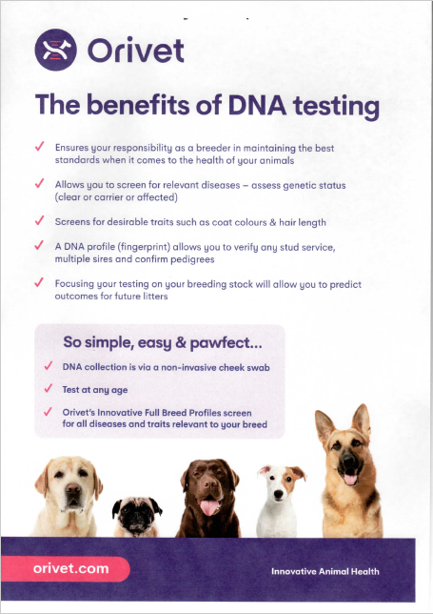

**TROPHY DONORS ACKNOWLEDGEMENT**

**The British Bulldog Club of NSW Inc. would like to thank the following   
people for their kind donations to our Championship Show**  
**THANK YOU!**

**PHIL ROBERTS**

**ROYAL CANIN**

**ORIVET**

**SUE DALEY**

**ANNE & CHRIS REES**

**DENISE DANIELS**

**COURTNEY & HAYDEN SMITH**

**ANN & CHRIS SMALL  
SUSAN DELLAS  
TRUDY DIVE**

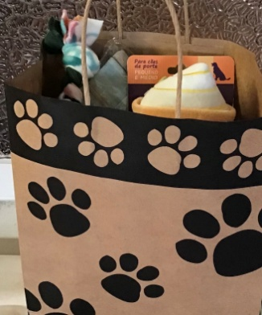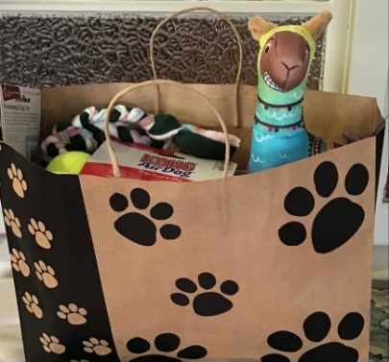

***raffle tickets $2 EACH, 3 FOR $5, 10 FOR $10***

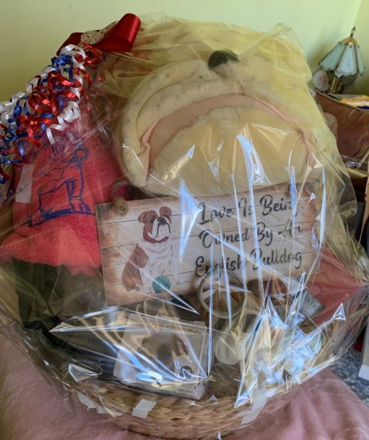

|  |  |  |
| --- | --- | --- |
| Class1 Entries 0  **Baby Puppy Dog** | | |
|  | | |
| Class 2  **Minor Puppy Dog** | | Entries 1 |
| 1 | Anthony Wilson | **NEVILLEBULL THE AUSSIE LAD** 2100591727 DOB 22/7/22 Sire: Bumbullb Hey Dam: Nevillebull Fatgirl  Breeder: Mrs M. Green |
| Show 1: First ....1...... Show 2: First ....1...... | | |
| Class 3  **Puppy Dog** | | Entries 1 |
| 2 | R. & N. Taylor & J. Gemmell | **EMBLLEM ENCANTO (AI)** 210588275 DOB2/6/22 Sire: The Crown of the Bulldog Carte D’or Dam: Llemmegs Darby Classic  Breeder: Exh. |
| Show 1: First ...2....... Show 2: First ...2....... | | |
| Class 4  **Junior Dog** | | Entries 1 |
| 3 | Mario Pace | **BUBBASBEST OSCAR WILD**  210581363 DOB 12/1/22 Sire: Ch Bubbasbest Wild Willy  Dam: Ch Hullabullula Lady Emelyn  Breeder: Exh. |
| Show 1: First ...3....... Show 2: First ...3....... | | |
| Class 5  **Intermediate Dog** | | Entries 1 |
| 4 | Sue Gibbons | **CH OMAGGIO ON THE DOUBLE** 2100546469 Dob 22/07/2020 Sire: Buldawg Handiwork Dam: Omaggio Rubies R Red  Breeder: Rochelle Andrews |
| Show 1: First .....4..... Show 2: First .....4..... | | |

|  |  |  |  |  |  |  |
| --- | --- | --- | --- | --- | --- | --- |
| Class 8  **Limit Dog** | | | | Entries 2 | | |
| 5 | | Susan Dellas | | **SAWYERMOON ALADDIN (ai) RN**  2100524857 DOB 20/7/19  Sire: Ndl Ch Testwood Tom  Dam: Provost Isleiona  Breeder: Exh. | | |
| A  6 | | Ken Trueman & Phil Roberts | | **TRUWINKS GAMBLING MAN**  2100536845 DOB 08/02/2020  Sire: Ch Embolden Rule Breaker  Dam: Ch Hefty Ramblinrose Breeder: Ken Trueman | | |
| Show 1: First ....5...... Show 2: First ....5...... | | | | | | |
| Class 10  **Australian Bred Dog** | | | | Entries 2 | | |
| 7 | | Glenn Edmunds Hayden & Courtney Smith | | **CH BRITISHEXTRA THE KINGSMAN**  2100544051 DOB 2/3/20  Sire: UK Ch Gongar King Henry Bulls (impIrl)  Dam: Britishextra All Class  Breeder: Exh. | | |
| 8 | | Donna Whillock | | **BUMBULLB MY FATHERZ SON** 2100544478 DOB 10/6/20Sire: Ch Gladiatorbull Ivar the Boneless Dam: Bumbullb Rebel Child  Breeder: Exh. | | |
| Show 1: First ....7..... Second ....8...... Show 2: First ....7..... Second ....8...... | | | | | | |
| **Class 11**  **Open Dog** | | | | | Entries 2 | |
| 9 | | Donna Whillock | | | **CHARJABULL ANOTHA BRIKINTHWALL** 2100510625 DOB 24/10/2018 Sire: Buldawg Ted I Am Dam: Provost MySapphire Breeder: B & O Garas | |
| 10 | | | Glenn Edmunds Hayden & Courtney Smith, | | **SUP CH BRITISHEXTRA THE IRISHMAN** 2100544050 Dob 02/03/2020Sire: Uk. Ch. Gongar King Henry Bulls (imp Irl)  Dam: Britishextra All ClassBreeder: Exh. | |
| Show 1: First .....10..... Second ....9...... Show 2: First .....10..... Second ....9......  **Show 1: Challenge Dog ....10...... Reserve Challenge Dog ....3....  Show 2: Challenge Dog ....10...... Reserve Challenge Dog ....3....** | | | | | | |
| **BITCHES** | | | | | | | |
| Class 1a  Baby Puppy Bitch | | | | | | Entries 1 | |
| 11 | A. Barber | | | | | **LOVERBULL SHES BETTY WHITE**  2100593880 DOB 14/10/22  Sire: Sealaville He’s Tyler (impUK)  Dam: Borrissbull Cuddly Bear  Breeder: John Wylde | |
| Show 1: First ....11......  Show 2: First ....11...... | | | | | | | |
| Class 2a  Minor Puppy Bitch | | | | | | Entries 1 | |
| 12 | Tracy Klaack | | | | | **BOSTONLAKES QUEEN OF THE GAMBIT** 2100592222 DOB 30/8/22 Sire: Waneta Gambit UK  Dam: Bostonlakes Its A Love Story (ai) Breeder: B & L Baker | |
| Show 1: First ...12.......  Show 2: First ...12....... | | | | | | | |
| Class 3a Puppy Bitch | | | | | | Entries 1 | |
| 13 | R & N Taylor & J Gemmell | | | | | **EMBLLEM RAVE N READY** 2100587185 DOB2/5/22 Sire: UK Ch Merriveen Rough N Ready Dam: Thistlebull Miss Ruby Rose  Breeder: Exh. | |
| Show 1: First .....13.....  Show 2: First .....13..... | | | | | | | |
| Class 4a Junior Bitch | | | | | | Entries 1 | |
| 14 | R & N Taylor & J Gemmell | | | | | **EMBLLEM MAXX FACTOR**  2100587186 DOB2/5/22 Sire: UK Ch Merriveen Rough N Ready Dam: Thistlebull Miss Ruby Rose  Breeder: Exh. | |
| Show 1: First ....14......  Show 2: First ....14...... | | | | | | | |

|  |  |  |  |  |  |
| --- | --- | --- | --- | --- | --- |
| Class 5a Intermediate Bitch | | | | Entries 2 | |
| 15 | | Hayden & Courtney Smith | | **BULLMAJESTY LOCKDOWN**  2100572827 DOB 11/9/2021  Sire: Ch Britishextra The Irishman  Dam: Bratrice Breaking The Ice  Breeder: Exh. | |
| Show 1: First ...15......  Show 2: First ...15...... | | | | | |
| Class 8a  Limit Bitch | | | | Entries 1 | |
| 16 | | Susan Dellas | | **SAWYERMOON GUINEVERE** 210082762 DOB 29/1/22 Sire: Ch Bubbasbest Wild Willy Dam: Sawyermoon Goldilocks Breeder: Exh. | |
| Show 1: First ....16......  Show 2: First ....16...... | | | | | |
| Class 10  Australian Bred Bitch | | | | Entries 2 | |
| A  17 | | Sharon Phegan | | **BRATRICE BITTER SWEET**  2100555692 DOB 30/11/2021  Sire: Ch Gladiatorbul Ivar The Boneless  Dam: Bratrice Taste The Rainbow  Breeder: Exh. | |
| 18 | | R & N Taylor & J Gemmell | | **EMBLLEM READY TO RAZZLE**  2100587188 DOB2/5/22 Sire: UK Ch Merriveen Rough N Ready Dam: Thistlebull Miss Ruby Rose  Breeder: Exh. | |
| Show 1: First ....18...... Second .......... Show 2: First ....18...... Second .......... | | | | | |

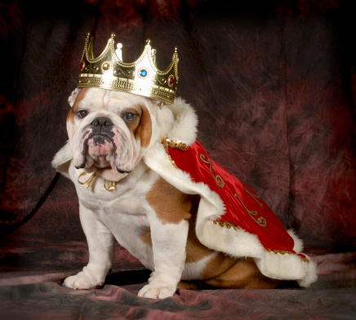

|  |  |  |  |  |  |  |
| --- | --- | --- | --- | --- | --- | --- |
| Class 11  Open Bitch | | | | | Entries 2 | |
| 19 | | Vince Henebery | | | **WONDERBULL SHELLY** 2100557987 DOB 15/2/21 Sire: Buldawg Huggy Bear Dam: Wonderbull Miss Melody Breeder: Exh. | |
| 20 | | Ken Trueman | | | **CH HEFTY RAMBLING ROSE**  2100485436 DOB 19/10/2017  Sire: Llemmegs Hobtop Gold Nugget (ai)  Dam: Ch Hefty Justa Joy  Breeder: Narelle Spencer | |
| Show 1: First ...19..... Second ...20......  Show 2: First ...19..... Second ...20......  Challenge Bitch ...15....... Reserve Challenge Bitch ....19......  **Best of Breed** ....10...... **Runner Up Best of Breed** ....15...... | | | | | | |
| **Class 18**  **Neuter Dog** | | | | Entries 0 | | |
| Class 18a  **Neuter Bitch** | | | | Entries 1 | | |
| 21 | | Susan Dellas | | **BULDAWG LOVELY TO LOOK AT**  2100425696 DOB 4/4/15  Sire: Ch Sawyermoon Lord Grantley  Dam: Buldawg Paparazzi Target  Breeder: Robert & Carla Smith | | |
| 1st Show: First ...21..... **Best Neuter ....21......** 2nd Show: First ...21.....  **Best Neuter ....21......** | | | | | | |

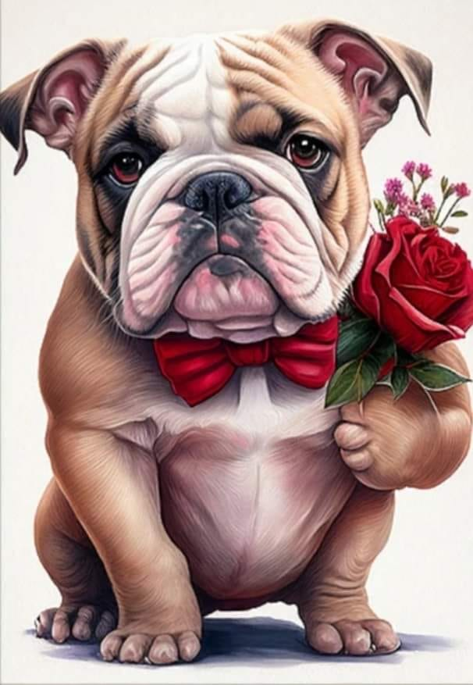

|  |  |  |  |  |  |  |  |  |  |  |  |  |  |  |  |  |  |  |  |  |  |  |  |  |  |  |  |  |  |  |  |  |  |  |  |  |  |  |  |  |  |  |  |  |  |  |  |  |  |  |  |  |  |  |  |  |  |  |  |  |  |  |  |  |  |  |  |  |  |  |  |  |  |  |  |  |  |  |  |  |  |  |  |  |  |  |  |  |  |  |  |  |  |  |  |  |  |  |  |  |  |  |  |  |  |  |  |  |  |  |  |  |  |  |  |  |  |  |  |  |  |  |  |  |  |  |  |  |  |  |  |  |  |  |  |  |  |  |  |  |  |  |  |  |  |  |  |  |  |  |  |  |  |  |  |  |  |  |  |  |  |  |  |  |  |  |  |  |  |  |  |  |  |  |  |  |  |  |  |  |  |  |  |  |  |  |  |  |  |  |  |  |  |  |  |  |  |  |  |  |  |  |  |  |  |  |  |  |  |  |  |  |  |  |  |  |  |  |  |  |  |  |  |  |  |  |  |  |  |  |  |  |  |  |  |  |  |  |  |  |  |  |
| --- | --- | --- | --- | --- | --- | --- | --- | --- | --- | --- | --- | --- | --- | --- | --- | --- | --- | --- | --- | --- | --- | --- | --- | --- | --- | --- | --- | --- | --- | --- | --- | --- | --- | --- | --- | --- | --- | --- | --- | --- | --- | --- | --- | --- | --- | --- | --- | --- | --- | --- | --- | --- | --- | --- | --- | --- | --- | --- | --- | --- | --- | --- | --- | --- | --- | --- | --- | --- | --- | --- | --- | --- | --- | --- | --- | --- | --- | --- | --- | --- | --- | --- | --- | --- | --- | --- | --- | --- | --- | --- | --- | --- | --- | --- | --- | --- | --- | --- | --- | --- | --- | --- | --- | --- | --- | --- | --- | --- | --- | --- | --- | --- | --- | --- | --- | --- | --- | --- | --- | --- | --- | --- | --- | --- | --- | --- | --- | --- | --- | --- | --- | --- | --- | --- | --- | --- | --- | --- | --- | --- | --- | --- | --- | --- | --- | --- | --- | --- | --- | --- | --- | --- | --- | --- | --- | --- | --- | --- | --- | --- | --- | --- | --- | --- | --- | --- | --- | --- | --- | --- | --- | --- | --- | --- | --- | --- | --- | --- | --- | --- | --- | --- | --- | --- | --- | --- | --- | --- | --- | --- | --- | --- | --- | --- | --- | --- | --- | --- | --- | --- | --- | --- | --- | --- | --- | --- | --- | --- | --- | --- | --- | --- | --- | --- | --- | --- | --- | --- | --- | --- | --- | --- | --- | --- | --- | --- | --- | --- | --- | --- | --- | --- | --- | --- | --- | --- | --- | --- | --- | --- | --- | --- |
| General Specials Show 1  April 2nd 2023 10am Mr Rory Lowe (NZ)   |  |  |  |  |  |  |  |  | | --- | --- | --- | --- | --- | --- | --- | --- | | Best in Show | | 10 | Runner Up Best in Show | | | | 15 | | Baby Puppy in Show | | 11 | Opp. Baby Puppy in Show | | | | - | | Minor Puppy in Show | | 12 | Opp. Minor Puppy in Show | | | | 1 | | Puppy in Show | | 2 | Opp. Puppy in Show | | | | 13 | | Junior in Show | | 3 | Opp Junior in Show | | | | 14 | | Intermediate in Show | | 15 | Opp. Intermediate in Show | | | | 4 | | Limit in Show | | 16 | Opp. Limit in Show | | | | 5 | | Aust. Bred in Show | | 7 | Opp. Aust. Bred in Show | | | | 18 | | Open in Show | | 10 | Opp. Open in Show | | | | 19 | | Challenge Dog | | 10 | Reserve Challenge Dog | | | | 3 | | Challenge Bitch | | 15 | Reserve Challenge Bitch | | | | 19 | | Best Veteran | | - | Opp. Veteran | | | | - | | Best Neuter | | 21 | Opp Neuter | | | | - | | General Specials Show 2 April 2nd 2023 12pm Mr Aaron Scott Go (ph)   |  |  |  |  | | --- | --- | --- | --- | | Best in Show | 15 | Runner Up Best in Show | 10 | | Baby Puppy in Show | 11 | Opp. Baby Puppy in Show | -- | | Minor Puppy in Show | 12 | Opp. Minor Puppy in Show | 1 | | Puppy in Show | 2 | Opp. Puppy in Show | 13 | | Junior in Show | 3 | Opp Junior in Show | 14 | | Intermediate in Show | 15 | Opp. Intermediate in Show | 4 | | Limit in Show | 5 | Opp. Limit in Show | 16 | | Aust. Bred in Show | 7 | Opp. Aust. Bred in Show | 18 | | Open in Show | 10 | Opp. Open in Show | 19 | | Challenge Dog | 10 | Reserve Challenge Dog | 3 | | Challenge Bitch | 15 | Reserve Challenge Bitch | 19 | | Best Veteran | - | Opp. Veteran | -- | | Best Neuter | 21 | Opp Neuter | -- |   **Done by Carla Parr during lunch break**  **Property Classes** | | | | | | | | | Best Head including Ears & Jaw | | | | | 2 | | | | Best Body including Front & Feet  Best Movement including Hindquarters with Action | | | | | 3 | | | | 19 | | | | Best Show Condition Parent & Offspring | | | | | 14 | | | | - | | | | Fancy Dress | | | | | 21 | | | | **Handler Classes** | | | | | | | | | Gentleman Handler |  | | | Lady Handler | |  | | | Novice Handler |  | | | New Member | |  | | | Tiny Tots Fun class |  | | | Child Handler 7-9 | |  | | | Child Handler 10-12 |  | | | Child Handler 13-17 | |  | | |

