Easter Championship Show
April 18th 2021
Bruce Parker Memorial Show
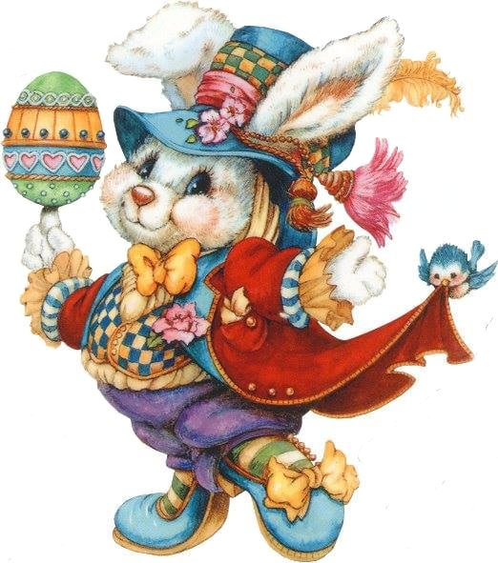
Sponsored by Royal Canin
Judge Mr Ken Hammond A.F.S.M.

The British Bulldog Club of NSW Inc.
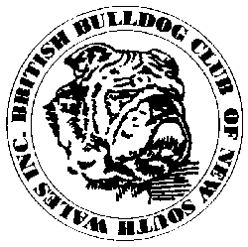

Executive: President: Mr Chris Small Hon. Secretary: Mrs Ann Small
Treasurer: Mrs Tracey Smith Assist. Secretary: Mrs Courtney Smith
Senior Vice President: Mrs Susan Dellas Junior Vice President: Mr Hayden Smith
Committee: Narelle Darragh, Mrs Denise Daniels, Mr Heath Smith, Mr Mario Pace,
Mrs Courtney Smith, Mr Robert Smith, Mrs Lisa Snow
Publicity Officer: Mrs Carla Smith
Show Manager: Mr Chris Small Assistant Show Manager: Mr Hayden Smith
Trophy Steward: Mrs Courtney Smith Assistant Trophy Steward: Mrs Tracey Smith

Life Patrons Mr Bruce Palmer (dec.) Life Patroness: Mrs Jennifer Prien (dec.)
Mr John Gemmell

Life Members: Mr J Gemmell Mr M Gooi Mrs J Penny Mrs J Prien (dec)
Mrs D Roberts Mr P Roberts Mrs C Smith Mr W Stacey (dec.)

We would like to welcome our Judge today.
We hope he enjoys our breed and our breeders.

OUR JUDGE TODAY ....................... Mr Ken Hammond (nsw)

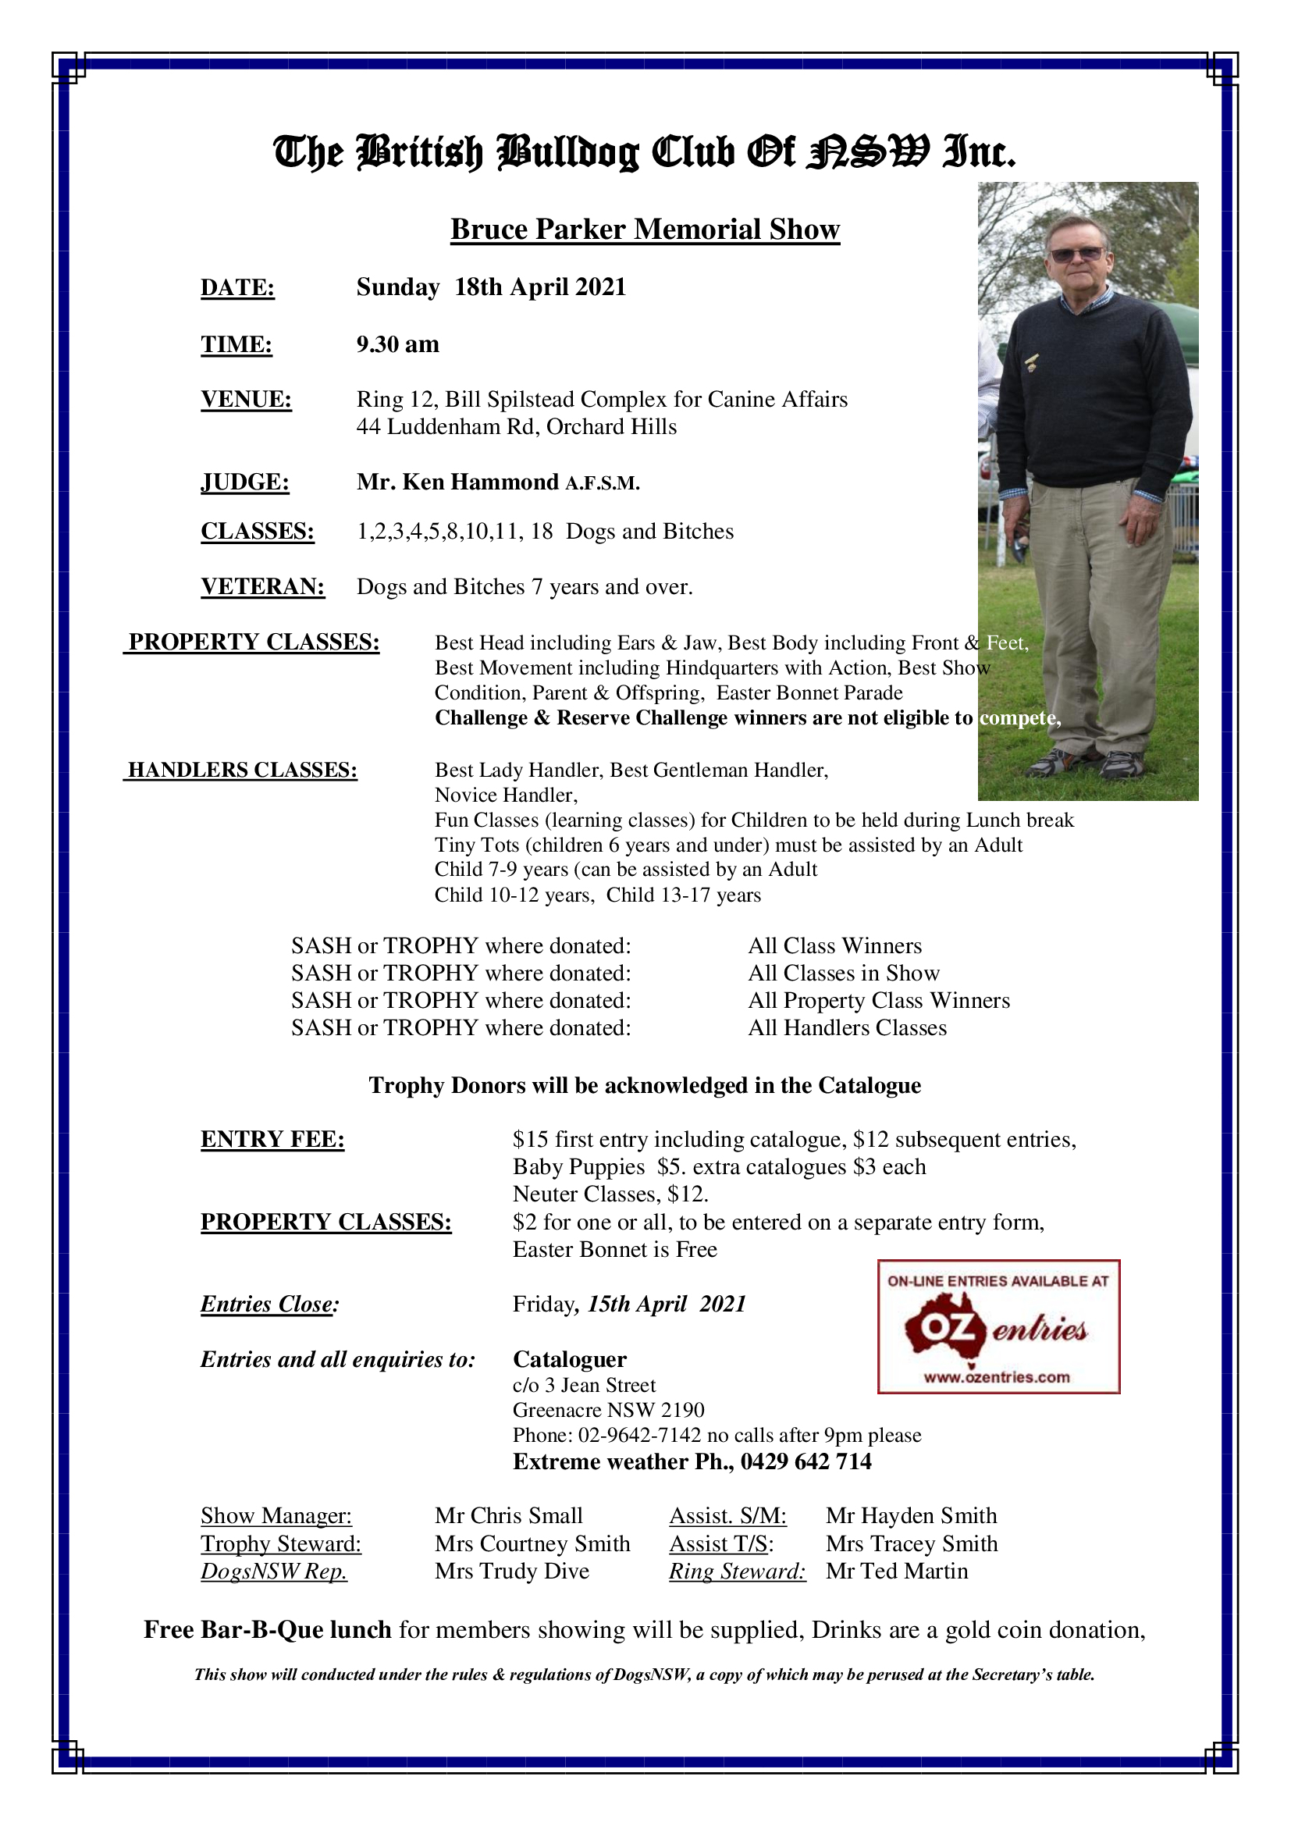
TROPHY DONORS ACKNOWLEDGEMENT
The British Bulldog Club of NSW Inc. would like to thank the following
people for their kind donations to our Championship Show
THANK YOU!

Mr Ken Hammond - Best in Show

Courtney & Hayden Smith
Ann Small & Chris Small
Llemmegs British Bulldogs
Robocky British Bulldogs
Ichellemay British Bulldogs
Avae British Bulldogs
Wonderbull British Bulldogs
Klicklaack British Bulldogs
Omana British Bulldogs
Bubbasbest British Bulldogs
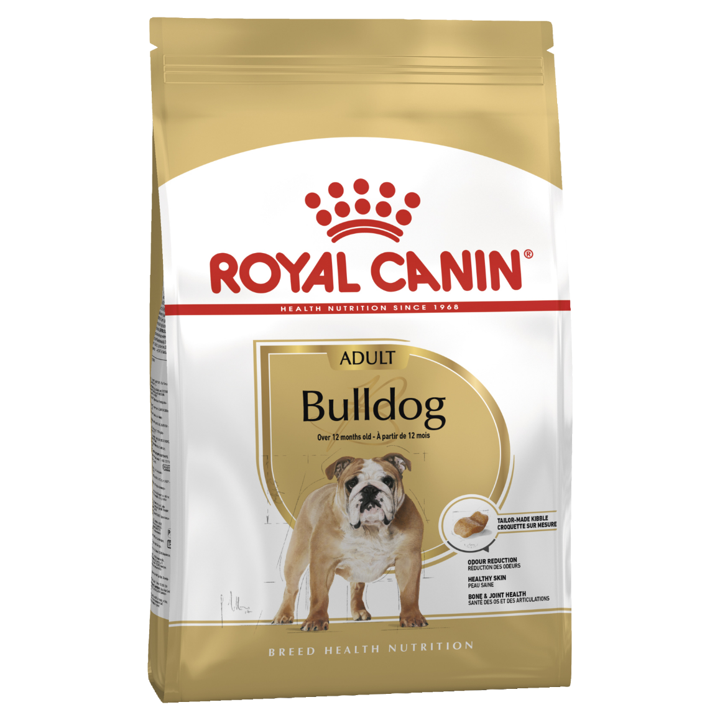

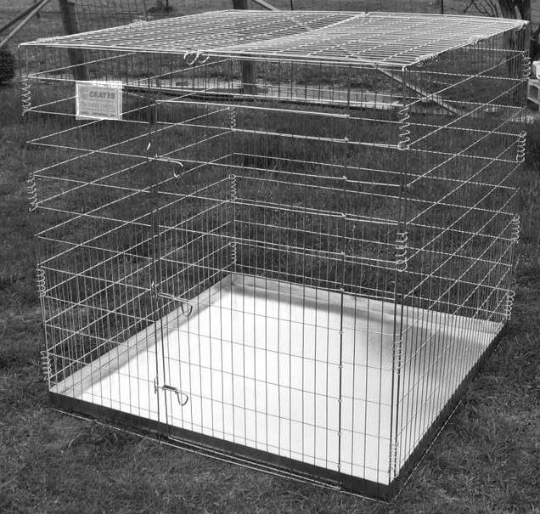

RAFFLE
REMEMBER TO BUY TICKETS FOR THE RAFFLE - DRAWN TODAY
C-Crates X Pen
tickets are $2.00 each
3 for $5.00, 7 for $10
won by Carla Smith
Class 1
Baby Puppy Dog Entries 3
1 | I & R Ansley | SAWYERMOON CHESTER  2100tba DOB 2/1/2021  Sire: Provost The Old Pretender  Dam: Sawyermoon Goldilocks  Breeder: Susan Dellas
2 | John Gemmell | LLEMMEGS MAN O WAR  2100555659 DOB 11/12/2020  Sire: Thistlebull Might N Power  Dam: Unforgetabul Good As Gold  Breeder: Exh
3  A | L. Letch & S. Fox | SAWYERMOON CARBINE  2100tba DOB 2/1/2021  Sire: Provost The Old Pretender  Dam: Sawyermoon Goldilocks  Breeder: Susan Dellas
First ....1...... Second ....2...... Third ..........

Class 3  Puppy Dog |  | Entry 1
4 | Donna Whillock | BUMBULLB MY FATHERZ SON  2100544478 DOB 10/6/20  Sire: Ch Gladiatorbul Ivar The Boneless  Dam: Bumbullb Rebel Child  Breeder: Exh.
First ...4.......

Class 4  Junior Dog |  | Entries 2
5 | Glenn Edmunds  Hayden & Courtney Smith | BRITISHEXTRA THE IRISHMAN  2100544050 DOB 2/3/20  Sire: UK Ch Gongar King Henry Bulls (impIRL)  Dam: Britishextra All Class  Breeder: Exh.
6 | Phil Roberts &  Ken Trueman | TRUWINKS GAMBLING MAN  2100536845 DOB 8/2/20  Sire: Ch Embolden Rule Breaker  Dam: Ch Hefty Ramblin Rose  Breeder: Ken Trueman
First .....5..... Second .....6.....

Class 5  Intermediate Dog |  | Entries 5
7 | Susan Dellas | SAWYERMOON ALADDIN  2100524857 DOB 20/7/19  Sire: Ndl Ch Testwood Tom (impUK)  Dam: Provost Isleiona  Breeder: Exh.
8 | Alison Lang | PROVOST THE OLD PRETENDER  2100525096 DOB 19/8/19  Sire: Bubbasbest Wild Willy  Dam: Ch Provost Prudence  Breeder: Exh
9  A | Alison & Kieran McGuire | IRONBULL PANDA FEARLESS  2100528570 DOB 9/9/19  Sire: Ch Llemeggs Sherman Tank  Dam: Eshad McGuire  Breeder: A & K McGuire
10 | P. Stuart | BEEMAN LAMELO BALL  2100526550 DOB28/8/19  Sire: Ch Bullyoyo Halloween (impEsp)  Dam: Beeman Sassy Sexy Wiggle  Breeder: S. Hurford & K. Todd
11 | Donna Whillock | BUMBULLB HEYY  2100527389 DOB 7/9/19  Sire: Bumbullb Breakin Heartz  Dam: Bumbullb I Wear Da Pants  Breeder: Exh.
First ....7...... Second .....10..... Third .....8.....

Class 8  Limit Dog |  | Entries 2
12  A | Phil & Di Roberts | HEFTY ICE BREAKER  210043554 DOB 28/8/15  Sire: Muscenny Supa Nova  Dam: Ch Hefty Justa Joy  Breeder: Narelle Spencer & Val Philip
13 | Narelle Spencer & Val Philip | HEFTY LIGHTNING STRIKE  210043555 DOB 28/8/15  Sire: Muscenny Supa Nova  Dam: Ch Hefty Justa Joy  Breeder: Exh.
First .....13..... Second ..........

Class 10  Australian Bred Dog |  | Entries 2
14 | Glenn Edmunds  Hayden & Courtney Smith | BRITISHEXTRA THE KINGSMAN  2100544051 DOB 2/3/20  Sire: UK Ch Gongar King Henry Bulls (impIRL)  Dam: Britishextra All Class  Breeder: Exh.
15 | Mario Pace | BUBBASBEST WILD WILLY  2100503004 DOB 10/6/18  Sire: Ch Provost The Young Pretender  Dam: Bbbull Jay jay  Breeder: Exh.
First ....14...... Second .....15.....

Class 11  Open Dog |  | Entries 3
16 | John Gemmell | CH LLEMEGS SHERMAN TANK  2100439348 DOB 6/10/15  Sire: Truwinks Prince Fredrick (ai)  Dam: Embolden All About Eevee  Breeder: Exh.
17 | Courtney & Hayden Smith | Srb CH MAUMI WALTHER (impSrb)  J474320 DOB 2/7/17  Sire: Multi Ch Home Pilar Kilombo  Dam: Mne Ch. Mac Ch Maumi History (Srb)  Breeder: Ivana Brdarevic
18 | Narelle Spencer & Val Philip | CH HEFTY GAME CHANGER  2100485433 DOB 19/10/17  Sire: Llemmegs Hobtops Gold Nugget  Dam: Ch Hefty Just Joy  Breeder: Exh.
First ....16...... Second .....17..... Third ......18....

Challenge Dog ............5.................
Reserve Chall Dog ...........14......................

Class 18  Open Neuter Dog |  | Entries 1
19 | Susan Dellas | CH SAWYERMOON EARL OF TESTWOOD (ai)  2100462540 DOB 3/11/16  Sire: Ndl Ch Testwood Tom (uk)  Dam: Buldawg Lovely To Look At  Breeder: Exh.
First ..19........
Best Neuter Dog ..19........

BITCHES

Class 1a  Baby Puppy Bitch |  | Entries 4
20  A | Steven Hurford & Karen Todd | BEEMAN QUEEN LETIZIA  2100552335 DOB 7/11/20  Sire: Beeman Exceed and Excel  Dam: Bullyoyo Daka (impEsp)  Breeder: Exh.
21 | Alison Lang | SAWYERMOON GLENCOE  2100 DOB 2/1/21  Sire: Provost The Old Pretender  Dam: Sawyermoon Goldilocks  Breeder: Susan Dellas
22 | Courtney & Hayden Smith | BULLMAJESTY WINK AND SHES GONE  2100075303 DOB 17/12/20  Sire: Srb Jr Ch Ch Maumi Walther (impSRB)  Dam: Ch Bratrice Breaking The Ice  Breeder: Exh.
23 | Lisa Snow | SAWYERMOON AURARIA  2100 DOB 2/1/21  Sire: Provost The Old Pretender  Dam: Sawyermoon Goldilocks  Breeder: Susan Dellas
First ....21...... Second ....23...... Third .....22.....

Class 2a  Minor Puppy Bitch |  | Entries 1
24 | Mario Pace | BUBBASBEST MAGIC MARLIN  2100550335 DOB 7/9/20  Sire: Ch Bubbasbest Wild Willy  Dam: Bubbasbest She Is A Dozzey  Breeder: Exhibitor
First .....24.....

Class 3  Puppy Bitch |  | Entries 2
25  A | Tracey Albrecht & Courtney & Hayden Smith | ROBOCKY CHANEL NUMBER  4100337674 DOB 13/6/20  Sire: Uk Ch Gongar King Henry Bulls (impIrl)  Dam: Ch Gladiatorbul Colosseum Queen  Breeder: Tracey Albrecht, C& H Smith
26 | Susan Dellas | DABELL LADY SATISFACTION  3100410598 DOB 22/6/20  Sire: Dexlum Missing Lincoln (ai)  Dam: Dabell Iron Pixie  Breeder: D & D Whebell
First ....26...... Second ..........

CLASS 4A  JUNIOR BITCH |  | Entry 2
27  A | Tracey Albrecht  Courtney & Hayden Smith | ROBOCKY CAMILLA WITH LOVE  4100337673 DOB 3/6/20  Sire: Uk Ch Gongar King Henry Bulls (impIrl)  Dam: Ch Gladiatorbul Colosseum Queen  Breeder: Tracey Albrecht, C & H Smith
28 | Narelle Spencer & Val Philip | KOARRA BURLESQUE BABY  2100530907 DOB 21/11/19  Sire: Hefty Widow Maker  Dam: Koarra Miss Izzy (ai)  Breeder: S & S Daley
First .....28..... Second ..........

CLASS 10A  AUSTRALIAN BRED BITCH |  | ENTRIES 3
29  A | Steve Hurford & Karen Todd | BEEMAN BANG BANG BOOM  2100526555 DOB 28/8/19  Sire: Ch Bullyoyo Halloween (impEsp)  Dam: Ch Beeman Sassy Sexy Wiggle  Breeder: Exh.
30  A | Ken Trueman | CH HEFTY RAMBLING ROSE  2100485436 DOB 19/10/17  Sire: Llemmegs Hobtop Gold Nugget (ai)  Dam: Ch Hefty Justa Joy  Breeder: N. Spencer & V. Philip
31 | Toni Whillock | BUMBULLB I WEAR DA PANTZ  2100492149 DOB 10/2/18  Sire: Sup Ch Janayin who Wears Da Pantz  Dam: Bumbullb Rebel Child  Breeder: Donna Whillock
First ....31...... Second .......... Third ..........

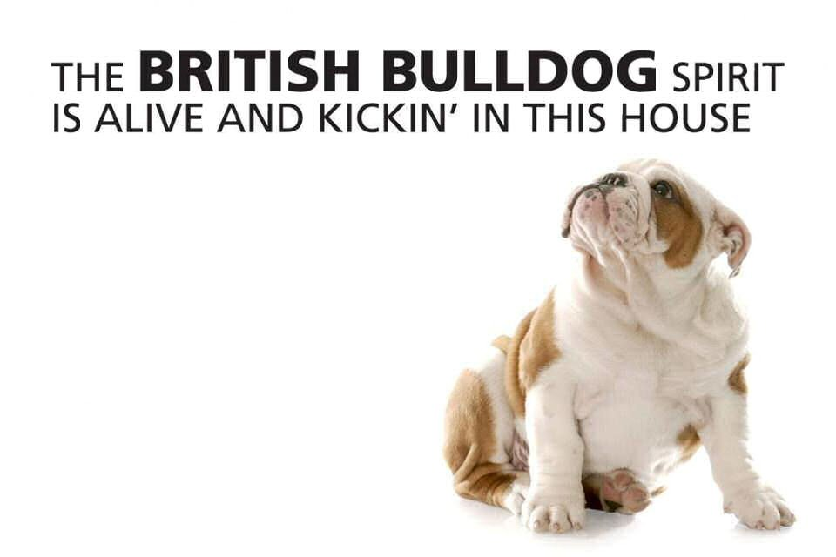
CLASS 11A  OPEN BITCH |  | ENTRIES 2
32 | Courtney & Hayden Smith | CH BRATRICE BREAKING THE ICE  2100481238 DOB 26/8/17  Sire: Sealaville He’s Bruce (impUK)  Dam: Bratrice In My Own Sweet Time  Breeder: Sharon Edmunds
33 | Narelle Spencer & Val Philip | CH HEFTY JUSTA JOY  2100391861 DOB 24/8/13  Sire: Ch Bratrice Natural Justice  Dam: Hefty Deck The Halls  Breeder: Exh
First ...32....... Second .....33.....

CHALLENGE BITCH .............32.................

RESERVE CHALLENGE BITCH .............26..........................

BEST IN SHOW ...5.......

RUNNER UP BEST IN SHOW .....32.....Bes........

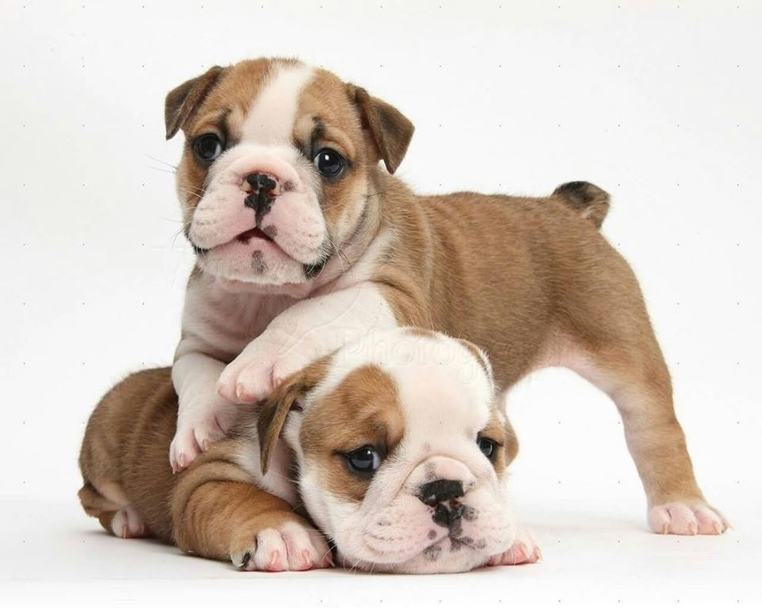
CLASS 18A  OPEN NEUTER BITCH |  | Entries 2
34 | Susan Dellas | BULDAWG LOVELY TO LOOK AT  2100425696 DOB 9/11/13  Sire: Ch Sawyermoon Lord Grantley (ai)  Dam: Buldawg Paparazzi Target  Breeder: R & C Smith
35 | John Gemmell | EMBOLDEN ALL ABOUT EVEE  2100695469 DOB 9/11/13  Sire: Ourstyle Call Me Erik (ai)  Dam: Embolden Fantasma  Breeder: Rick & Narelle Taylor
39 | Alison Lang | CH PROVOST PRUDENCE  2100409481 DOB 24/6/2014  Sire: Provost Crxus  Dam: Provost Softail Classic  Breeder: Exhibitor
First ....34...... Second .....39..... Third ....35......

VETERANS
Veteran Dog |  | Entries 1
36  A | M. B. McAdam | GATELY SAME THING CLASSIC  2100282984 DOB 12/4/2013  Sire: Gateley Kimberley  Dam: Ch Gateley White Magnolia  Breeder: Exhibitor
First ..........

Veteran Bitch |  | Entries 1
33 | Narelle Spencer & Val Philip | CH HEFTY JUSTA JOY  2100391861 DOB 24/8/13  Sire: Ch Bratrice Natural Justice  Dam: Hefty Deck The Halls  Breeder: Exh
First ....33......

Best Veteran ...33.......
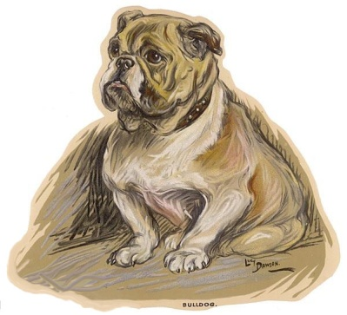

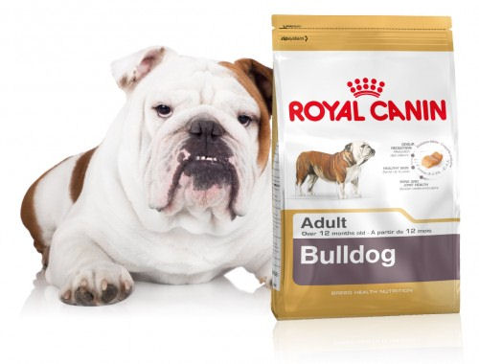
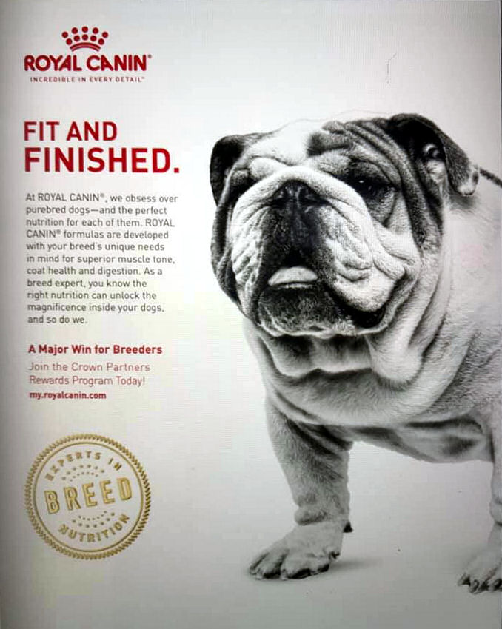

General Specials
April 18th 2021
Best in Show |  | 5 | Runner Up Best in Show |  |  |  | 32
Baby Puppy in Show |  | 21 | Opposite Baby Puppy in Show |  |  |  | 1
Minor Puppy in Show |  | 24 | Opp. Minor Puppy in Show |  |  |  | --
Puppy in Show |  | 26 | Opp. Puppy in Show |  |  |  | 4
Junior in Show |  | 5 | Opp Junior in Show |  |  |  | 28
Intermediate in Show |  | 7 | Opp. Intermediate in Show |  |  |  | --
Limit in Show |  | 13 | Opp. Limit in Show |  |  |  | --
Aust. Bred in Show |  | 14 | Opp. Aust. Bred in Show |  |  |  | 31
Open in Show |  | 32 | Opp. Open in Show |  |  |  | 16
Challenge Dog |  | 5 | Reserve Challenge Dog |  |  |  | 14
Challenge Bitch |  | 32 | Reserve Challenge Bitch |  |  |  | 26
Best Veteran |  | 33 | Opp. Veteran |  |  |  | --
Best Neuter |  | 19 | Opp Neuter |  |  |  | 34
Property Classes

Best Head including Ears & Jaw |  |  |  |  | 8
Best Body including Front & Feet  Best Movement including Hindquarters with Action |  |  |  |  | 8
 |  |  |  |  | 8
Best Show Condition  Parent & Offspring |  |  |  |  | 8
 |  |  |  |  | 8 & 21
Fancy Dress |  |  |  |  | 34
Handler Classes

Gentleman Handler | Mario Pace |  |  | Lady Handler |  | Narelle Spencer
Novice Handler | Ivana Ansley |  |  | New Member |  | --
Tiny Tots Fun class | 5-15-33-6-8 |  |  | Child Handler 7-9 |  | Greta Snow
Child Handler 10-12 | 15--26 |  |  | Child Handler 13-17 |  | Isabella Snow

STUD & KENNEL ADVERTISERS PAGE
BEIZERBULI BULLDOGS  Ms Kerry Dunne  29a Phyllis Street  Mt Pritchard 2170  M: 0422-815-986 #2000798580 | BRATRICE BRITISH BULLDOGS  Breed information  & Puppy enquires  welcome  At Stud: Ch Bratrice Deal Breaker  Sharon Edmunds  4 Watt Street  Windermere Park 2264  M: 0414-729-809  e-mail bratrice@bigpond.com #2000782790
BULDAWG BRITISH BULLDOGS  Robert & Carla Smith  Breed information  & Puppy enquires  welcome  Jean Street  Greenacre 2190  Ph: 02-9642-7142  E: buldawg@bigpond.net.au #2000256150 | BULDOK BRITISH BULLDOGS  At Stud:  Ch Buldok Our Sampson  Buldok Omeley  Ch Buldok Buff  Ch Buldok Boris  Wayne & Shane Cooper  22 Maud Street  Cardiff South 2285  P: 4954-7439  E: amandacooper@optusnet.com.au #2100027626
BUMBULLB BRITISH BULLDOGS  At Stud to Approved bitches:  Ch BumbullB Redfred  Grd Ch Janayin Who Wears Da Pants  Ch Bumbullb Withya Pantz Down  Donna Whillock  Picton, NSW  M: 0409-966-372  E: donna.whillock22@gmail.com #2100016325 | EMBOLDEN BULLDOGS  At Stud to Approved bitches  Ch Embolden Rule Breaker  Ch Embolden Right Said Fred  Ch Ocobo Red Sunset (impUK)  Rick & Narelle Taylor  Thirroul NSW  M: 0406-431-578  E: emboldenbulldogs@bigpond.com #2006981220
KARMABULLZ  Toni Whillock  East Parade  Buxton 2571  M: 0437-763380  michael_harris_1987@outlook.com #2100072976 | GODLLUBEM BRITISH BULLDOGS  Deborah Drysdale Puppies sometimes available  Liverpool 2170  M: 0432-277-293  E: deborah_drysdale@hotmail.com #2100041328
HEFTY BRITISH BULLDOGS  Breed information, stud &  puppy enquires welcome  puppies sometimes available  Narelle Spencer & Val Philip  P: 02-9543-4079  E: n.spencer@exemail.com.au #2100343312 | KARSLEMAINE BRITISH BULLDOGS  breed information, stud &  puppy enquiry’s welcome  at stud: Ch Karslemaine Kassius Klay  Ch Wonderbull Ali B Back  Cindy Elliott  Vidler Court  Landsborough, 4550  M: 0467-081-516  E: karslemaine@hotmail.com #4004591840
KOARRA BRITISH BULLDOGS  Breed information, stud &  puppy enquires welcome  Sue Daley  596 Creak Ridge  Freemans Reach 2756  P: 02-4579-6503 #2100022840 | LLEMMEGS BRITISH BULLDOG  John & Liane Gemmell  Breed information, stud & puppy enquires welcome  61 Gerald Road  Illawong, 2234  P: 02-9543-4779  E: llemmegs@optusnet.com.au #2000687650
MUSCENNY BRITISH BULLDOG  Breed information, stud &  puppy enquires welcome  Anne & Chris Rees  6 Grevillia Ave  Davistown 2251  P: 02-4369-1650 #2000818460  E: muscennydogschris@gmail.com #2100067387 | PROVOST BRITISH BULLDOGS  Robert & Allison Lang  Breed information, stud &  puppy enquires welcome  The Ironbarks  Picton 2566  M: 0419-261-689  E: provostbulldogs@gmail.com #2000729310
SAWYERMOON KENNELS  At stud to approved bitches  Ch Sawyermoon Lord Grantley  Susan Dellas  Faulconbridge 2776  02-4751-7312  E: barbarag@bigpond.net.au #2100033973 | WONDERBULL BRITISH BULLDOGS  Vince & Wanda Henebery  Breed information, stud &  puppy enquires welcome  P.O. Box 196  Culburra Beach NSW 2540  P: 0412-731-372  E: vincewanda@bigpond.com #2000257560
BULLMAJESTY KENNELS  Courtney & Hayden Smith  P.O. Box 7291  Mount Annan 2567  M: 0406-928-105  E: courtney@terracivil.com.au #2100075303  Breed information  puppies sometimes available | DISCLAIMER The Breeders who appear throughout this magazine and or web-site are merely breeders that The British Bulldog Club of NSW Inc. understands may have litters for sale. In providing you with their details The British Bulldog Club of NSW Inc. makes no representations as to the reputation of any breeder or as to the soundness or suitability of any puppy you may decide to acquire from any breeder. You must satisfy yourself that any puppy you may decide to acquire is healthy, sound and meets your requirements. The B. B. C. of NSW Inc. accepts no responsibility in respect of the information contained in its magazine and or web-site in respect of any puppy that you may decide to acquire from any breeder in it. Any personal disputes between members/buyers are a private or domestic nature and do not involve The B.B. C. of NSW Inc. and should be properly resolved by the courts or the Department of Fair Trading All breeders who are current members of Dogs NSW have agreed to abide by the Dogs NSW Regulations, including the Code of Ethics.
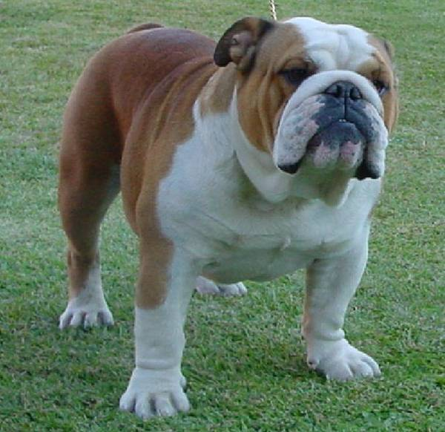

Just for fun
MBIS MBISS CH BULDAWG OUR MAN GODFREY
BEST IN SHOW
SYDNEY ROYAL 2004

