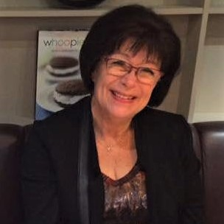
RESUME : CHAMPIONSHIP SHOW JUDGE MONICA MATTFOLK

First of all, I would like to extend a warm thank you for this invitation to come and judge your dogs, I feel honored and proud of the mission.
Here is a short presentation of me. I have bred Newfoundland's dog since 1978 and have been successful in exhibitors, our breeding has won "Newfoundland Dog of the Year" several times.
In 1994 we bought a wonderful Sheltie female from kennel Starbelle (CH Station Hill Crackshot-CH Starbelle Simply Splendid) and she was mated with CH Bermarks Upside Down .
Two boys were born, we kept one of them, which later became INT & NORD UCH Yosemite's Following Star. He became very successful even as a Stud dog and several of his offspring became Champions.
His daughter Ch Lundecocks Xit from Paradise who became Best in Show all breeds. We mated her with CH Japaro by Design and saved Yosemite's Design for me , also he became a Champion and has been very successful at the sired . He will soon be 10 years old and is very happy and cheerful.
We are very grateful that we have had the opportunity to import dogs from kennel Degallo and kennel Ellenyorn, Scotland, it has been very fortunate. CH Degallo the Wicca Man still exists in our lines. In Sweden, we have for several years had a good cooperation with kennel Sheldon. We are so grateful for the great cooperation we have had with various kennels that have had confidence in us.
I became an authorized FCI judge in 1994, then on Newfoundland's dog.Today I am also authorized at Landseer, Entlenbuchen, Appenzellen, Shetland Sheepdog, Rough and Smooth Collie and Briard.
I have been honored to judge my breeds at Special club Shows , FCI exhibitions in Europe and Russia. The finest assignments I have had is that I have been judging Sheltie at Scottish Breed in Edinburgh and Sheltie males at SSSK's main exhibition in Vilsta. I have also had the honor to Judge Shetland Sheepdog as well as Rough and Smooth Collie at the FCI Nordic winner.

Sincerely
Monica Mattfolk

